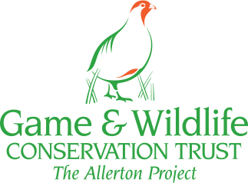 | “Trees and Livestock”  Farm Woodland Forum  Annual Meeting at GWCT Allerton Project, Loddington, Leicestershire  10-11th July 2018 | 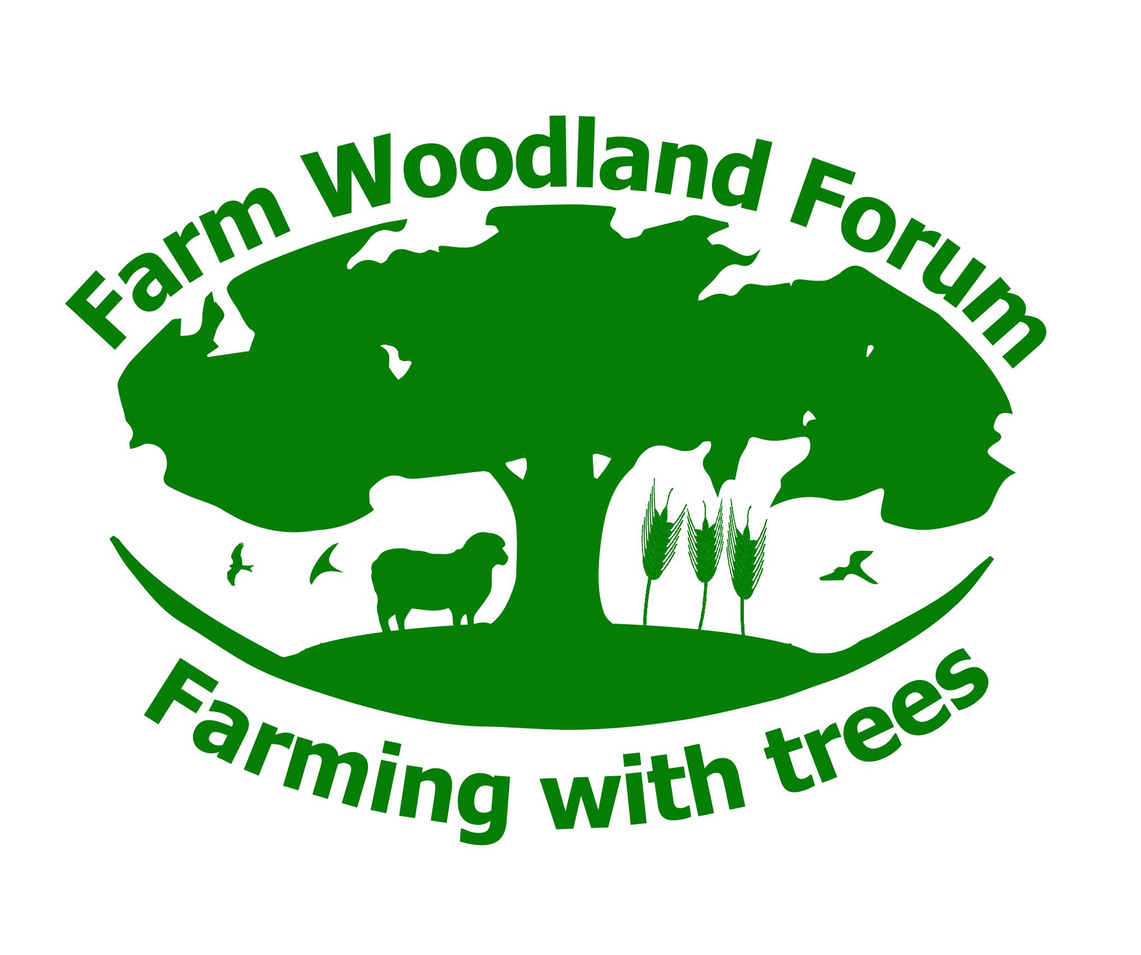
Abstracts
Trees and Livestock
Lindsay Whistance, Organic Research Centre: How trees can benefit livestock
Much of what an animal does each day is linked to maintaining an internal and external balance (homeostatic equilibrium). For example, hunger, heat or fear will trigger behaviours that are aimed at seeking food, shade or distance from the source of fear. For all species of farmed animals, trees can play a valuable role in the maintenance of homeostatic equilibrium and on many levels. Social relations improve in silvopasture where cattle stay closer together and social licking, as a percentage of all social interactions, is 78%, almost twice that of cows on open pasture. Grooming is an innate behaviour that aids the removal of dead skin, hair or fleece, external parasites and plant seeds that can penetrate the skin. A variety of heights and angles of trunks and branches enables animals to manage their own coats. Although chickens preen using their beaks, they do more of this when under a tree canopy. Tree canopies and shelter belts can provide protection from cold winds, rain and frost, reducing the energy levels required to maintain body temperature and significantly increasing the survival rates of newborn lambs. Globally, the single most important role of trees is to provide shade. Well-designed silvopasture can reduce solar radiation by up to 58% as well as improving air circulation. Animals in silvopasture utilise their environment more evenly and maintain normal daily patterns of behaviour more closely than animals on open pasture, where much feeding behaviour is replaced with loafing behaviour in hot weather. Feeding animals on leaves and twigs, either as direct browse or as preserved tree fodder, offers multiple benefits. In nutritional terms, some tree species compare well with grasses grown in the same environment and they can be a very good source of minerals. The presence of condensed tannins increases the level of high-quality rumen-bypass protein in the diet and they act as a natural control for gastro-intestinal parasites. Salicylic acid is a recognised pain suppressant (aspirin) that also has anti-inflammatory and mild antibiotic properties and this is abundant in some tree species such as willow and poplar. There is increasingly strong evidence that farm animals can self-treat nutritional imbalances and can self-medicate when their environment is sufficiently diverse to allow them to do so. In all, trees can help animals to maintain or regain homeostatic equilibrium by benefitting social cohesion, acting as a buffer in most weather conditions and offering a good supplementary source of nutrition as well medication for pain and parasite control.

Jill Butler, Woodland Trust: The importance of historic pollards for livestock
Across Europe and into Turkey, trees have been cut as pollards since time immemorial. Different species of tree have been cut in a variety of traditional ways for a whole range of valuable products, but principally for tree ‘hay’ or fodder, fruits, wood fuel or building materials. From Scandinavia to the Mediterranean, from Portugal to Turkey. Interestingly the practice was not exported to the New World with European immigrants. Tree fodder from pollards helped farmers and commoners offset the risks that they faced from poor summers – principally drought but also high rainfall and long cold winters. Before the coming of oil and plastics they were essential for providing other essential household goods and were on the doorstep. This contrasts with coppice which was often unavailable to local communities as it was used for industrial purposes such as mining and smelting or exported away from the community to growing towns and cities. The importance of the cultural heritage value of the trees should be used to help justify the protection of ancient pollards and their historic landscapes as much as their biodiversity, ecosystem service and tourism values. It should also be used to encourage the establishment and cutting of new pollards to restore or renew traditional landscapes in the same way that historic buildings and archaeological artefacts are conserved for future generations to enjoy.
Paul Burgess, Cranfield University: Lessons learnt for livestock agroforestry in the AGFORWARD project
Paul Burgess, John E. Hermansen, Jo Smith, Monique Bestman, Boki Luske, Sandra Novak, Anne Grete Kongsted, Rosa Mosquera Losada, Valerio Bondesan, and Jim McAdam
This presentation will review the lessons learnt from using trees and shrubs in livestock systems from various stakeholder groups across Europe. The improved seasonality of grass production under trees was a key benefit within beef and sheep systems in Spain and the UK. In Epping Forest near London, the use of “invisible fencing” allow unconstrained public access to an important area for recreation. In Herefordshire, the use of sheep within high stem apple orchards reduced mowing costs and provided additional grass for sheep production. Work by the Organic Research Centre highlighted how grass swards can be established in poultry systems. In Italy and the Netherlands, trees reduced the level of heat stress experienced by outdoor pigs. Partners in the Netherlands led on the production of an tree fodder database, where leaves of black locust, chestnut, white mulberry and ash can have crude protein levels of 22%.

Hilary Ford, Bangor University: How do hedgerows influence soil organic carbon in livestock grazed pasture?
Hedgerows have the potential to enhance ecosystem service delivery in livestock-grazed pasture. Despite this, they are often ignored when quantifying ecosystem service provision at the landscape scale. As part of the Multi-Land project (http://www.nrn-lcee.ac.uk/multi-land/), we focused on the contribution of hedgerows to climate change mitigation via the ecosystem function of carbon storage, with a particular emphasis on soil organic carbon (SOC). We measured SOC (content and stock) in pasture adjacent to 38 hedgerows (biotic) and 16 stone walls or fences (abiotic control) in 9 farms within the Conwy catchment (Wales, UK). SOC content for pasture adjacent to both biotic and abiotic boundaries was positively associated with ‘soil moisture’ and negatively with ‘soil bulk density’. For biotic boundaries two further variables were significantly associated with SOC content, ‘perpendicular distance from hedgerow boundary’ (decrease in SOC) and ‘slope orientation in relation to hedgerow’ (upslope SOC greater than downslope). For pasture adjacent to hedgerows a model combining the four parameters listed above explained 78% of variation in SOC content. In contrast, predictive models of SOC stock lacked explanatory power due to the negative relationship between SOC content and soil bulk density. This study illustrates the importance of hedgerows, to SOC storage in the wider agricultural landscape.

Agroforestry in research, practice and development
Matthew Axe, Royal Agricultural University, Cirencester: Utilising hedgerows for landscape scale carbon sequestration
Hedgerows are a prominent agroforestry system in England and Wales, an estimated 456 000 km of these being actively managed. The use of hedgerows to sequester atmospheric carbon (C) was proposed by Falloon et al. 2004. Their models for field boundaries showed between 0.1 to 2.4% of 1990 UK CO₂-C emissions could be sequestered, however, hedgerow options focused on planting new hedges on existing arable field margins. Following a study of hedgerow C stocks on a lowland arable farm, the means in which existing hedgerow features could sequester C was scrutinised. This considers how long-term management cycles affect C stocks.

Ross Dickinson, Racedown Farm: A coppiced hedge: Converting a flailed hedge into an economic crop of firewood
This paper will demonstrate that it is economically viable to move a hedge from annual flailing to a fifteen-year coppicing rotation using our methods and applying our circumstances. It has been shown by others that the most efficient method is complete chipping of all material and the subsequent use of this material in biomass burners, both in terms of profitability and energy output. The problem with this process is that there is not currently enough demand for this type of material due to various factors including; many boilers not running well on this type of rough chip and that the current demand for chip in general is well below the potential supply. It may well be that in time we will achieve a complete supply and demand cycle as in certain areas of the continent, if this achieved on a scale that could absorb all the material from hedges then it is likely that this process will be widely adopted. If the example discussed here has any merit it is in its ordinariness. If this process is viable on our farm using our techniques then it should be widely applicable, or to put it more crudely, if we can do it then anybody can do it. The process used here requires no particular skill set, no special equipment and no demand for new capital. This paper will not provide a template for others to adopt as it is site specific but it does demonstrate that in certain circumstances it is viable to take some hedges from flailing to coppicing and that there will be parts of our process which others might adapt to their own circumstances.
Tom Staton, University of Reading: How can silvoarable systems be optimised to deliver ecosystem service benefits from biodiversity?
Tom Staton, Richard J Walters, Jo Smith, Helen Chesshire, Robbie Girling,
Silvoarable systems generally support higher biodiversity and abundances of ecosystem service providers, such as natural enemies of pests, compared to monocropped arable. However, effects differ between studies and non-significant effects are frequently reported. Nevertheless, our initial modelling results suggest that optimised pest regulation and pollination could reduce the time taken for silvoarable profitability to exceed an equivalent arable system by up to five years. This finding is constrained by a scarcity of empirical data regarding the actual functionality of ecosystem services such as pest regulation in these systems, trade-offs between services and disservices such as weed competition, and a limited understanding of how these services can be optimised through appropriate management. We are therefore collecting data on pest regulation and pollination from three silvoarable sites in the UK over three years, as part of a PhD investigating the influence of silvoarable management on biodiversity-derived ecosystem services.
Ian Lane, Ian Lane Associates: After thirty years UK agroforestry, are we barking up the wrong trees?
UK agroforestry has focussed on growing specimen trees for timber planted across arable fields or pastures. However this has several disadvantages such as long growth periods (30 - 100 years), low short term economic returns, long term threats from fungal diseases and pests - as well as major reduction in crop yields or pasture productivity (unless species with edible leaves are planted); in addition, it appears that for some species timber quality from comparatively fast grown widely spaced trees is poor compared to well managed forest grown trees. Should we not look to alternative markets - while biofuel is well catered for, there may be major potential to address the burgeoning eco-house market. In Sweden quality timber is shredded to produce wood wool, which is then bound with cement to form both wood wool cement insulation panels as well as large wall elements. These elements are non-load bearing, but a system using poured reinforced concrete frames has been developed. In the UK wood wool cement insulation can replace baled straw in eco-house construction (such as "Mod-Cell"), and give six hour fire resistance compared to only two hours for straw bales. Standard stud walls or I-frame construction to UK construction standards can be used for 40 cm wide wood wool cement insulated walls, and systems for local off-site production in "Pop-Up" factories developed. The key aspect for developing wood wool cement systems is that the wood wool can be produced by direct harvesting of short to long rotational coppice with a biomass harvester, or by mechanical pollarding of "windbreaks" with shredding of this growth on a four - six year rotation. This will result in early returns to the forestry component, while eliminating depression of crop and pasture yields currently experienced with mature trees. Small scale samples of wood wool / binder using various binders including PVA alone, cement + lime, lime + burnt gypsum, burnt gypsum alone, and clay/PVA will be shown, while Demo stud and I-frame walls will be presented for discussion.

Agroforestry in practice
Sally Westaway, ORC: UK Agroforestry Network (AFINET) opportunities and barriers
AFINET (Agroforestry Innovation Networks) is a European agroforestry initiative which aims to support innovation through enhancing knowledge transfer between farmers, foresters, researchers and advisers. In the UK, the AFINET project is led by the Organic Research Centre and Abacus Agriculture. Through a series of practical workshops and wider consultation with agroforestry practitioners in the UK we have identified the most common barriers to setting up new agroforestry systems and gaps in current information. Top barriers to adoption include uncertainties around the ongoing financial picture; lack of time, expertise and availability of practical advice to help with design and management. Access to case studies showcasing best practice and economic data to help with decision making were identified as major gaps in current knowledge. More clarity on the policy situation was also requested. Together with the Farm Woodland Forum we are working to address these barriers through shared experiences of managing existing systems, practical on farm training and workshops, and by improving access to existing knowledge.

Helen Chesshire, Woodland Trust: Overview of Woodland Trust funded agroforestry schemes
Since 2013 the Woodland Trust has been offering farmers across the UK advice and subsidized trees & protection to help them set up small scale agroforestry schemes. Hear descriptions of the types of schemes that have been planted as well as the challenges and the rewards to date. With the development of a new land management policy post Brexit these demonstration schemes are proving to be very useful in bringing agroforestry to forefront of policy makers’ minds. Hear our initial thought on how future schemes should support agroforestry and the role trees can play in supporting sustainable agriculture whilst delivering an array of public benefits.

Agroforestry in policy
Jim McAdam, AFBI, and Eugene Curran, Forest Service: Adoption of agroforestry options in land use policy measures in Northern and Southern Ireland
The research programme at AFBI Loughgall, Northern Ireland showed that silvopastoralism (wide spaced trees planted into grassland) can be a means of increasing tree cover and to facilitate sustainable intensification of grassland. Economic predictions and farmer surveys of agroforestry have been favourable but it is when agroforestry is accepted for state support that on-farm planting is likely to increase. In the current RDP (2014 -2020) agroforestry was included as an option in forestry measures in Ireland and in 2017 as an option in the Environmental Farming Scheme (ie an Agricultural measure) in Northern Ireland. In both measures, the planting and management specification stipulated was largely based on the research findings from the AFBI research programme. Uptake has been encouraging and these farmers and land owners will form the nucleus of a group of examples in practice which hopefully will encourage other participants.

