Report of the 2016 European Agroforestry Conference by William Considine

William Considine was one of the recipients of support from the Farm Woodland Forum to attend the 2016 European Agroforestry Conference. Below, William gives a brief report on the conference.

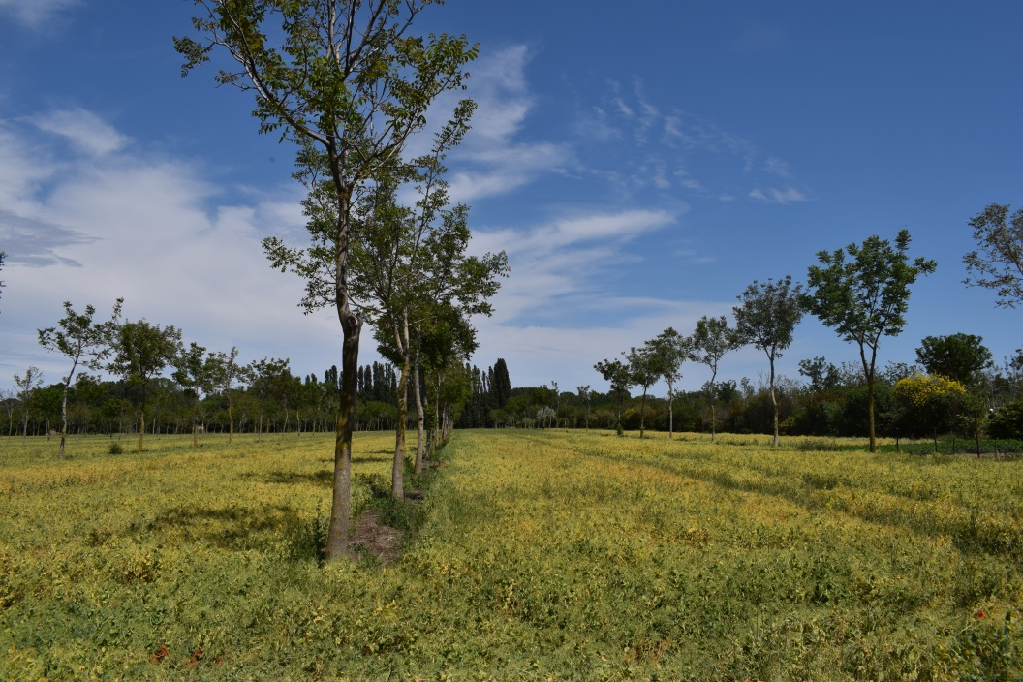
Production of walnut with an understorey crop in Southern France (Photo: Paul Burgess).

A journey into Agroforestry
I was in the South of France in late May 2016, in Montpellier and Toulouse to be precise. It was my first time in the great Languedoc wine growing region and I was looking forward to it. Even more than the place, I looked forward to the event - the third biennial conference of EURAF, the European federation of organisations that promote agroforestry. When it was founded just five years ago, I was proud to be one of the three Irish founder members but this was my first time to attend the conference.

France planning to have agroforestry on 50% of farms by 2025
The conference was the biggest and best yet with about 300 participants from 29 countries. It was opened by the French Minister for Agriculture, M. Stephane Le Fol. This is the man largely responsible for putting soil carbon into the Paris COP Climate Change Treaty. He has also brought in the "4 per thousand" plan to incentivise French farmers to rebuild their soil organic matter and put atmospheric carbon back in the soil. Their target of adding 0.4% per year to the amount of carbon held in soils to help offset most the carbon emissions from fossil fuels and ruminants. This is surely a better strategy than culling cows. Agroforestry will play a major role and their target is to have Agroforestry on 50% of French farms by 2015.

An Irish presence
The conference itself was a buzz with scientists, extension people and farmers and hundreds of papers and posters presented in parallel sessions on a wide range of topics. I was joined by Eugene Curran of the Forest Service and Liam Beechinor of Clonakilty. There was an excellent paper presented by Irish, Walsh Fellowship researcher, Rory Lunny on his trials at Loughgall on cultivating wild cherry trees inter-planted with short rotation willow. Two days of conference were sandwiched around a one day field tour where we got to visit a range of French farms implementing agroforestry. There was a great youthful "vibe" about the whole event and I managed to learn a lot, have some lovely food and wine and meet many great people.

Agroforestry is largely unknown among Irish Farmers, even though many of our traditional farming systems could be defined as agroforestry. Agroforestry is effectively the integration of trees with crops and/or livestock on the same area of land. The trees can be inside parcels or on the boundaries (hedges).

Protecting traditional farms and landscapes
A major impetus for the formation of EURAF was that mainstream CAP policies were increasingly impinging on traditional farming systems. A particular issue was the rule that any area eligible for single payment had to have fewer than 50 woody stems per hectare. We saw in recent years where many Irish farmers were penalised and forced to remove woody stems, e.g. furze [gorse], from fields where they had been providing soil stability, water retention, shelter, browsing, biodiversity and landscape colour for decades. In fact the ruling stated that eligible land must not have more than 50 "trees" per hectare but didn't define a tree. Thus a furze bush was treated equally with a mature oak tree creating the nonsense where a field with 49 huge oak trees per hectare could be eligible but one with 51 stems of furze was not.

A new vista emerges
I am happy to say that the establishment of EURAF to lobby the Commission on such matters has borne fruit. CAP 2014-2020 has raised the limit to a hundred trees per hectare and discussions are ongoing to set a minimum canopy width for defining a tree. The new flexibility that is developing, as well as giving some relief to traditional farmers, is opening up exciting new opportunities. There is much to be gained by adopting agroforestry. Apart from landscape, biodiversity, carbon sequestration, combating erosion and flooding, and providing additional income opportunities, scientific studies have shown that mixing tree growing and farming on the same parcels can increase total farm output by up to 50%.

Learning more
I personally hope that before this year is out, we may form an organisation in Ireland to affiliate to EURAF and work with the Department of Agriculture to access the opportunities that I believe to be there. If anyone would like to support and get involved I would love to hear from you at wmconsidine@gmail.com. I will be hosting an Irish Wood Producers agroforestry event here at my Nicharee-Farm on 20th October 2016.

