Farm Woodland Forum – Field Visit 2018 Annual Meeting

The delegates toured the experiments at the Allerton Project Loddington farm, led by Chris Stoate (GWCT Allerton Project).

Agroforestry Trial (with Stuart Holm, Woodland Trust)
The objectives of this trial were to 1) increase tree cover in the part of the farm where it is located 2) to explore the means of combining trees with grazed long-term pasture 3) to explore the trade-off between the first two objectives by having different tree densities. For many farmers, the key requirement of woodland planting is that it should not stop them being able to claim Basic Farm Payments (BFP), and grazing had to be maintained within the planting scheme to ensure this. The entire field in which the trial sits is still entitled to BFP.

The tree species (including walnut, oak, hornbeam, small-leaved lime, aspen, crab apple, field maple, cherry, hazel, hawthorn, wild privet and dogwood, but no conifers) were planted at a range of densities from 100 to 1600 stems per hectare. Densities of 1600 and 1100 trees per hectare had shrubs planted between, were grown for roosting sites for gamebirds, and fit in with a nearby shelterbelt. These plots are currently fenced to prevent sheep damage, but the shrubs will be sacrificed as they are not in the long-term plan for the plot. The trees planted at 100, 200 and 400 trees per hectare will be the mainstay of the agroforestry long term, and the intermediate densities will be harvested for woodchip to fuel the Allerton Project’s boilers.
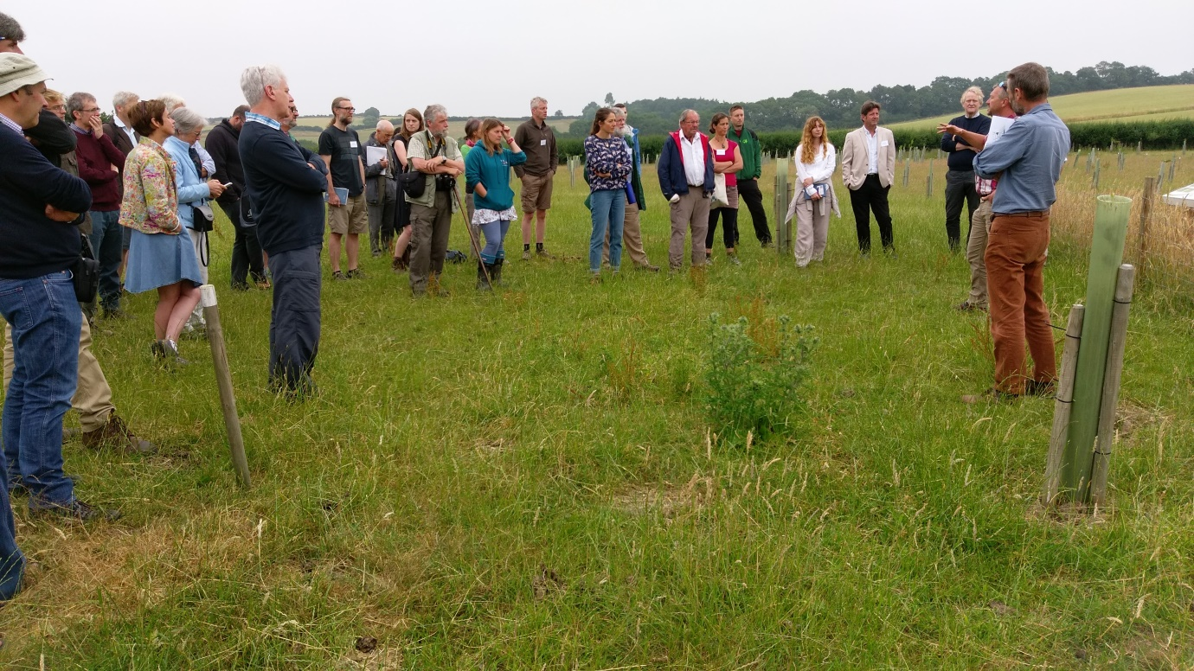
Stuart Holm explaining the site design to delegates.

At planting in March 2016, lines 2.5 metres apart were scribed into the field with a harrow, and the seedlings were planted at different distances on these lines to give the different densities. The lines were arranged in curves, to avoid straight lines in the landscape and to minimise wind exposure. The seedlings were protected with 1.2 m plastic tubes supported by 2 1.5 m x 50 mm diameter stakes, although experience after a two years’ sheep grazing indicates that 1.5 m tubes would have been better. The two stakes per tree were definitely required. There was no mulching round the seedlings, as emphasis was placed on maintain grazing rather than on the trees themselves. The tubes will probably be removed after 10 years.

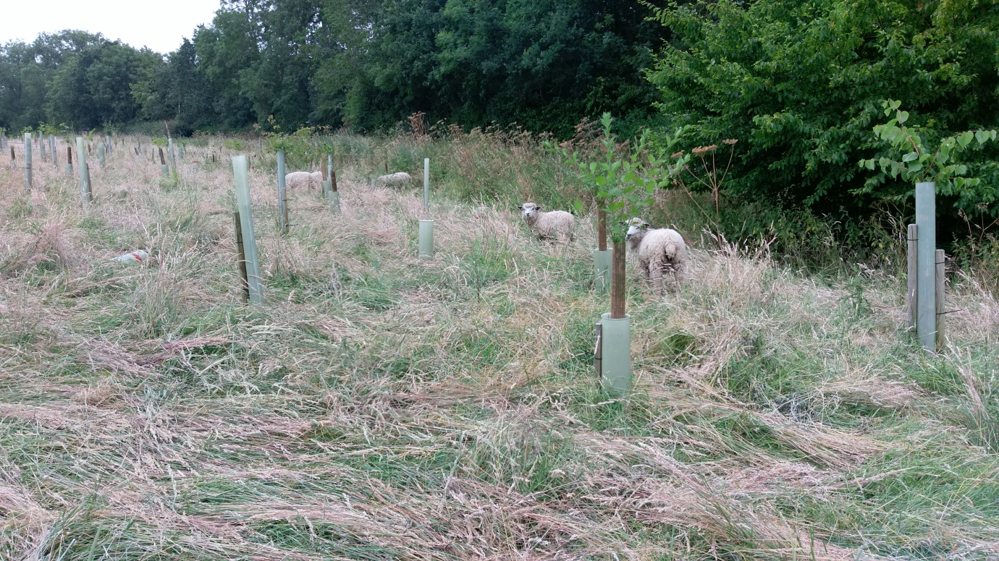
Sheep grazing in the agroforestry site.

Experimental analyses of light levels, soil properties (penetration and compaction) and soil biology (especially earthworms, 10 species of which have been found in this field) are being carried out.

The trial has been funded by the Woodland Trust.

Shelterbelts

The stands of trees at Loddington Farm, at the time of the GWCT taking over the farm, have been broken up to give a mosaic of habitats suitable for game birds. Shelterbelts have been maintained at key points to give shelter and roosting sites. The trees within them are thinned on a rotation, with felled wood being chipped and used to fuel the Allerton Project boilers (up to 15 t in the site thinned in each year). Muntjac deer are a problem for the trees, causing some damage.

Community Orchard

In one field at Loddington Farm a series of predominantly local varieties of apple were planted in 2010 as part of the farm’s Higher Level Stewardship Scheme contribution. These are mainly cooking varieties, as the local varieties happen to not include many dessert types, and include from Leicestershire Annie Elizabeth, Barnack Orange, Dumelow Seedling and Prince Charles, plus Cottenham Seedling (from Cambridgeshire), Loddington (perversely not from Leicestershire, but Burnley) and Peasgood Nonsuch (from Lincolnshire).
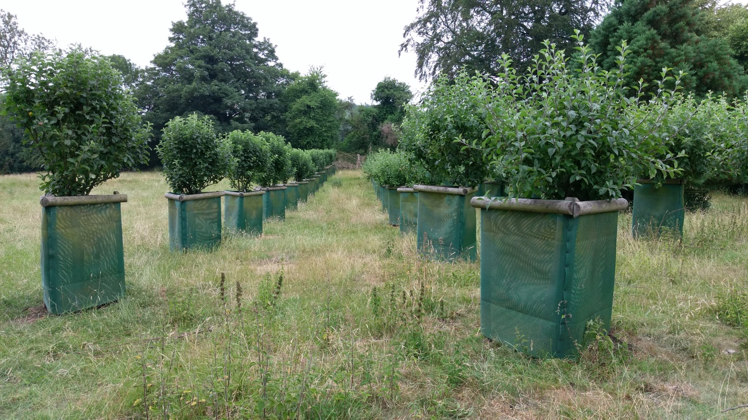
The community orchard.
The fruit are harvested and made into cider by a local company, currently the Kicking Bottle Cider Company, Hallaton. The field in which the apple trees are situated is grazed by sheep rotationally so the trees have been individually fenced off round each trunk. Local residents take some interest in the orchard, and give help with routine tasks.

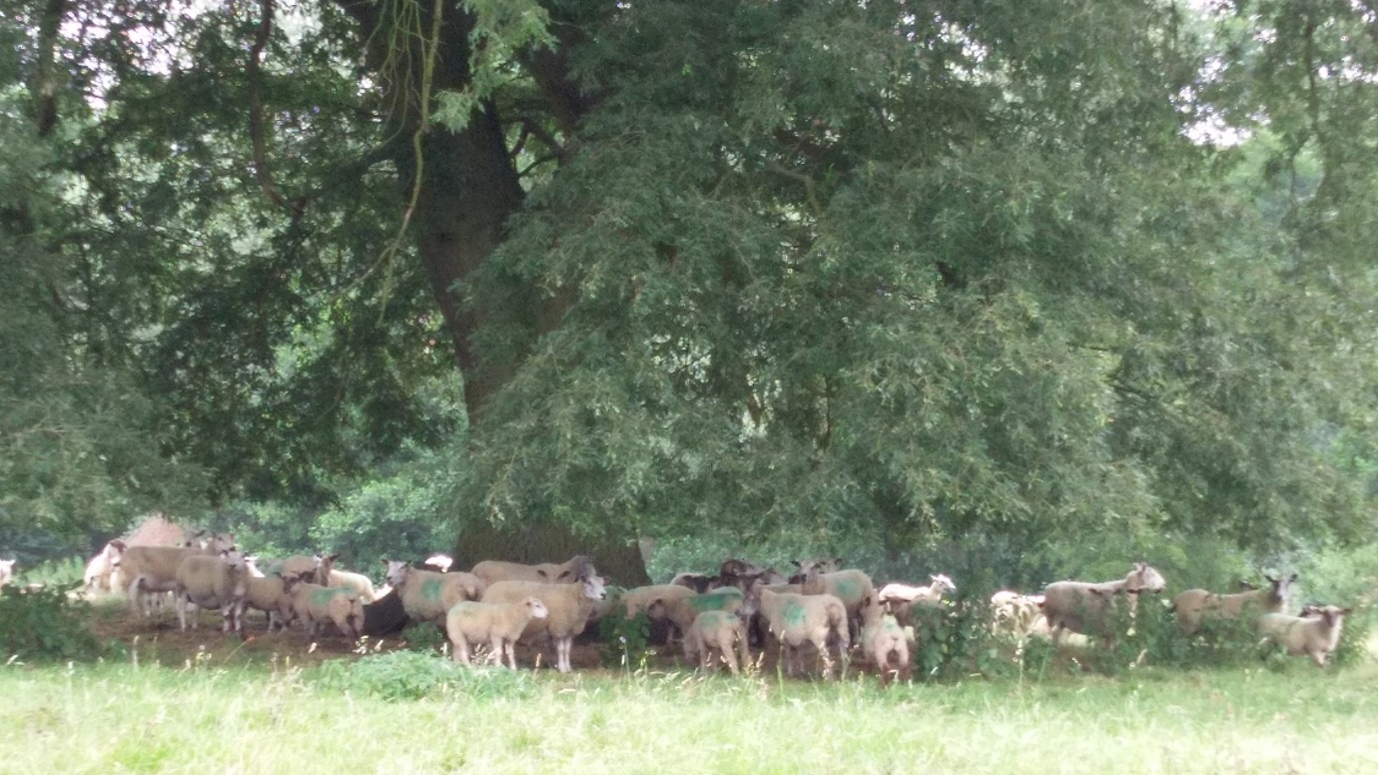
Sheep sheltering from the sun in the same field as the community orchard.

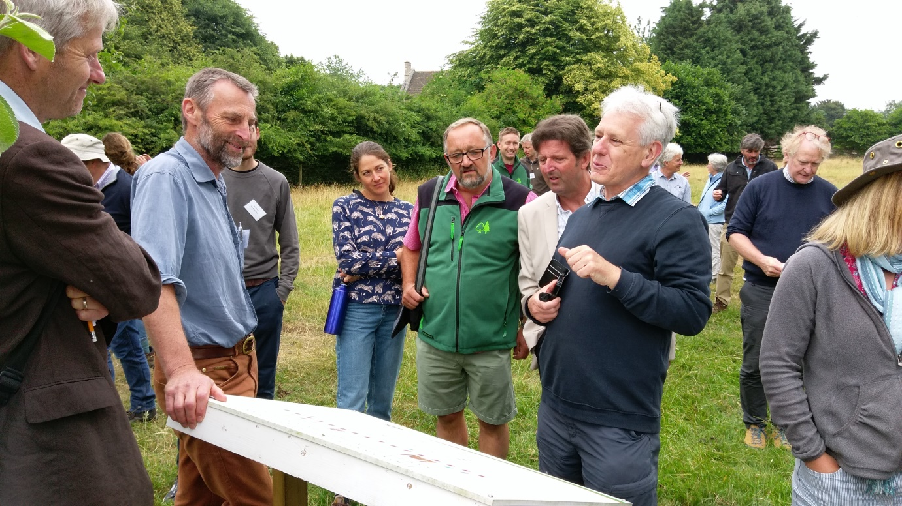
Thanks to Chris Stoate (holding information board) for leading the tour.

