Field Visits Report

18th/19th May 2015 Elm Farm, Organic Research Centre

Towards Eco-energetic Communities (TWECOM)

TWECOM is an EU-funded project running from January 2013 to September 2015 that aims to investigate the feasibility of producing biomass for local communities from existing features in the landscape such as hedgerows (www.twecom.eu).

The trial run by the Organic Research Centre is evaluating how much biomass can be produced from management of hedges both at Elm Farm and at Wakelyns in Suffolk, and carrying out a cost-benefit analysis of harvesting the biomass.

At Elm Farm, Mary Crossland and Meg Chambers showed delegates a 300 metre hedge that had been cut back to almost ground level by a variety of methods (manual felling with a two-man team, tree shears, tree shears plus chainsaw and assisted felling using a chain saw plus an excavator with a fork). The time taken for a set length of hedge to be felled had been measured, and from the costs of the operators plus equipment hire it was then possible to calculate the cost of felling a length of hedge. The operations had been replicated on a narrower hedgerow. At Wakelyns narrow and wide hedgerows had been felled manually, by circular saw and by a felling grapple.

The material felled at both sites was either chipped immediately by both a large and a small chipper, and the woodchip was left to dry in a barn before analysis of quality or the wood was left for 3 months before chipping.

Further details of the results of the trial are given with the proceedings of the Forum. Discussion of the experiment in the field centred round that facts that 1) the economic analysis was dependent on both the speed of operation of the contractors, which would have possibly been different after they had got used to carrying out the procedures on a longer length of hedgerow and if they knew that they were guaranteed a few days of work and if the charges that the contractors levied were not influenced by the fact that they knew this was a research project 2) the prices quoted for potential sale of the woodchip on the open market appeared to be low. However, if woodchip were to be produced from hedgerows the farmer would have to be certified in order for it to qualify for Renewable Heat Incentive payments 3) the
ash content of the woodchip was rather high, at nearly 3%, and the particle size distribution was considerable. . The presence of brambles etc. in the hedgerow had lowered the quality of the woodchip also.

The group also saw a hedge that had been cut back earlier, and allowed to regrow. Stool survival, biodiversity (including small mammals) and soil carbon are being monitored.

Agroforestry at Elm Farm

Delegates were shown 2 new plantings by Jo Smith and Hamish Thomson (Woodland Trust).

Tree avenue. A new avenue of sweet chestnut, oak, field maple, rowan, hornbeam, cider apples, dessert apples and pears had been planted, funded by the Woodland Trust.
Bioenergy production hedge. A hedge of hazel, sycamore, sweet chestnut and willow had been planted.

Both features were funded by the Woodland Trust. Trees were planted with protection from ‘ezee guards’ (made from recycled board). These had not lasted very well after the first year, due to wet conditions. The sweet chestnut trees had not become well established, possibly because they were small when planted and may have had insufficient light within the guards.

Delegates also saw an area of silvopastoral agroforestry with willows and common alder, funded as part of the EU Sustainable Organic and Low-Input Dairy (SOLID; www.solidairy.eu) project. The aim of the trial was to evaluate if coppiced trees grown for biomass could be integrated into low-input dairy systems. Productivity of the sward has been measured annually in a cut of silage, along with measures of biodiversity in the system, and production of biomass from the trees will be evaluated later.

The establishment of the willow had been very poor, due to deer grazing, but the alders had not been noticeably grazed and were well established. The system had originally been planted with 12 m pasture alleys, but due to difficulties with operating equipment half of the tree rows had been removed to give alleys of 24 metre. Trees had been planted into jute/hemp mulch strip, but this had only lasted for one year. In the second year black biodegradable plastic and wood chip were evaluated as mulch. The plastic only lasted for a year, but the woodchip gave longer cover. It was considered by the delegates that one year cover would be adequate for establishment of alder. It was noted that care will have to be taken to protect the trees if cattle are introduced into the system, rather than merely taking silage off the alleys.

Further details of the agroforestry projects are given with the Proceedings of the Forum. http://www.organicresearchcentre.com/?i=articles.php&art_id=773&go=Information and publications

19th May 2015. Visit to Little Hidden Farm, Hungerford, by kind invitation of Bill Acworth

The agroforestry at Little Hidden Farm in Berkshire consists of 5 ha planted in spring 1993 and a further 3.5 ha planted in 1994. These were planted as silvoarable agroforestry, within a cereal rotation, although since 2002 the alleys have been down to pasture and are grazed by sheep and are cut for silage.

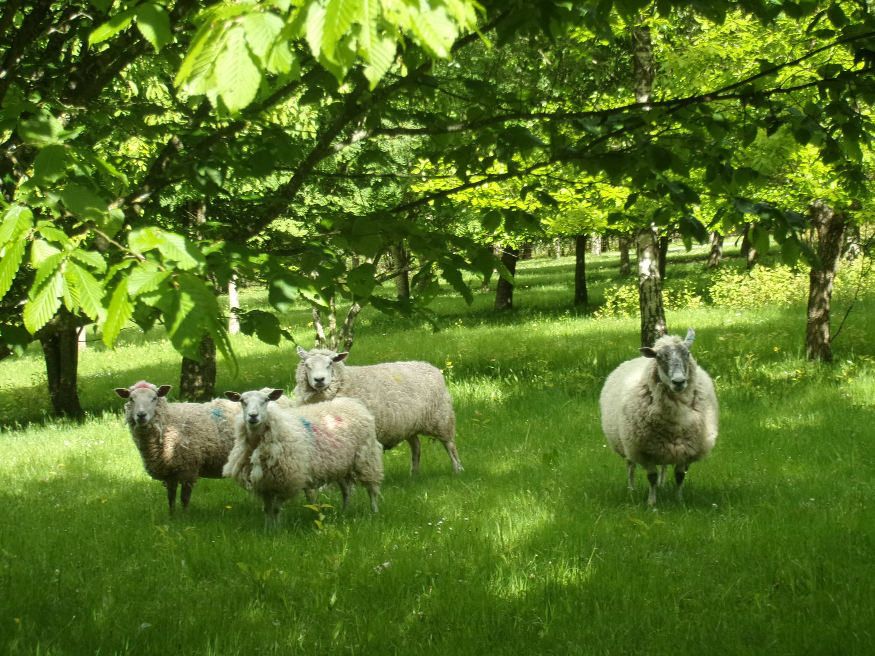
Barren ewes under the trees at Little Hidden Farm (photograph by Paul Burgess)

Trees (mainly ash, cherry, oak, sycamore and black walnut, with hornbeam, London plane, grey alder, lime, Norway maple, beech, copper beech, fern leaf beech and Turkish hazel as secondary species) were planted in single rows at a mean distance of 1.5 m apart, with 12 m alleys between the rows. The trees were high pruned. Some have been removed (sold as rooted trees for private houses and urban building projects). Some lime and alder trees are currently being pollarded, and the wood removed is to be used for heating.

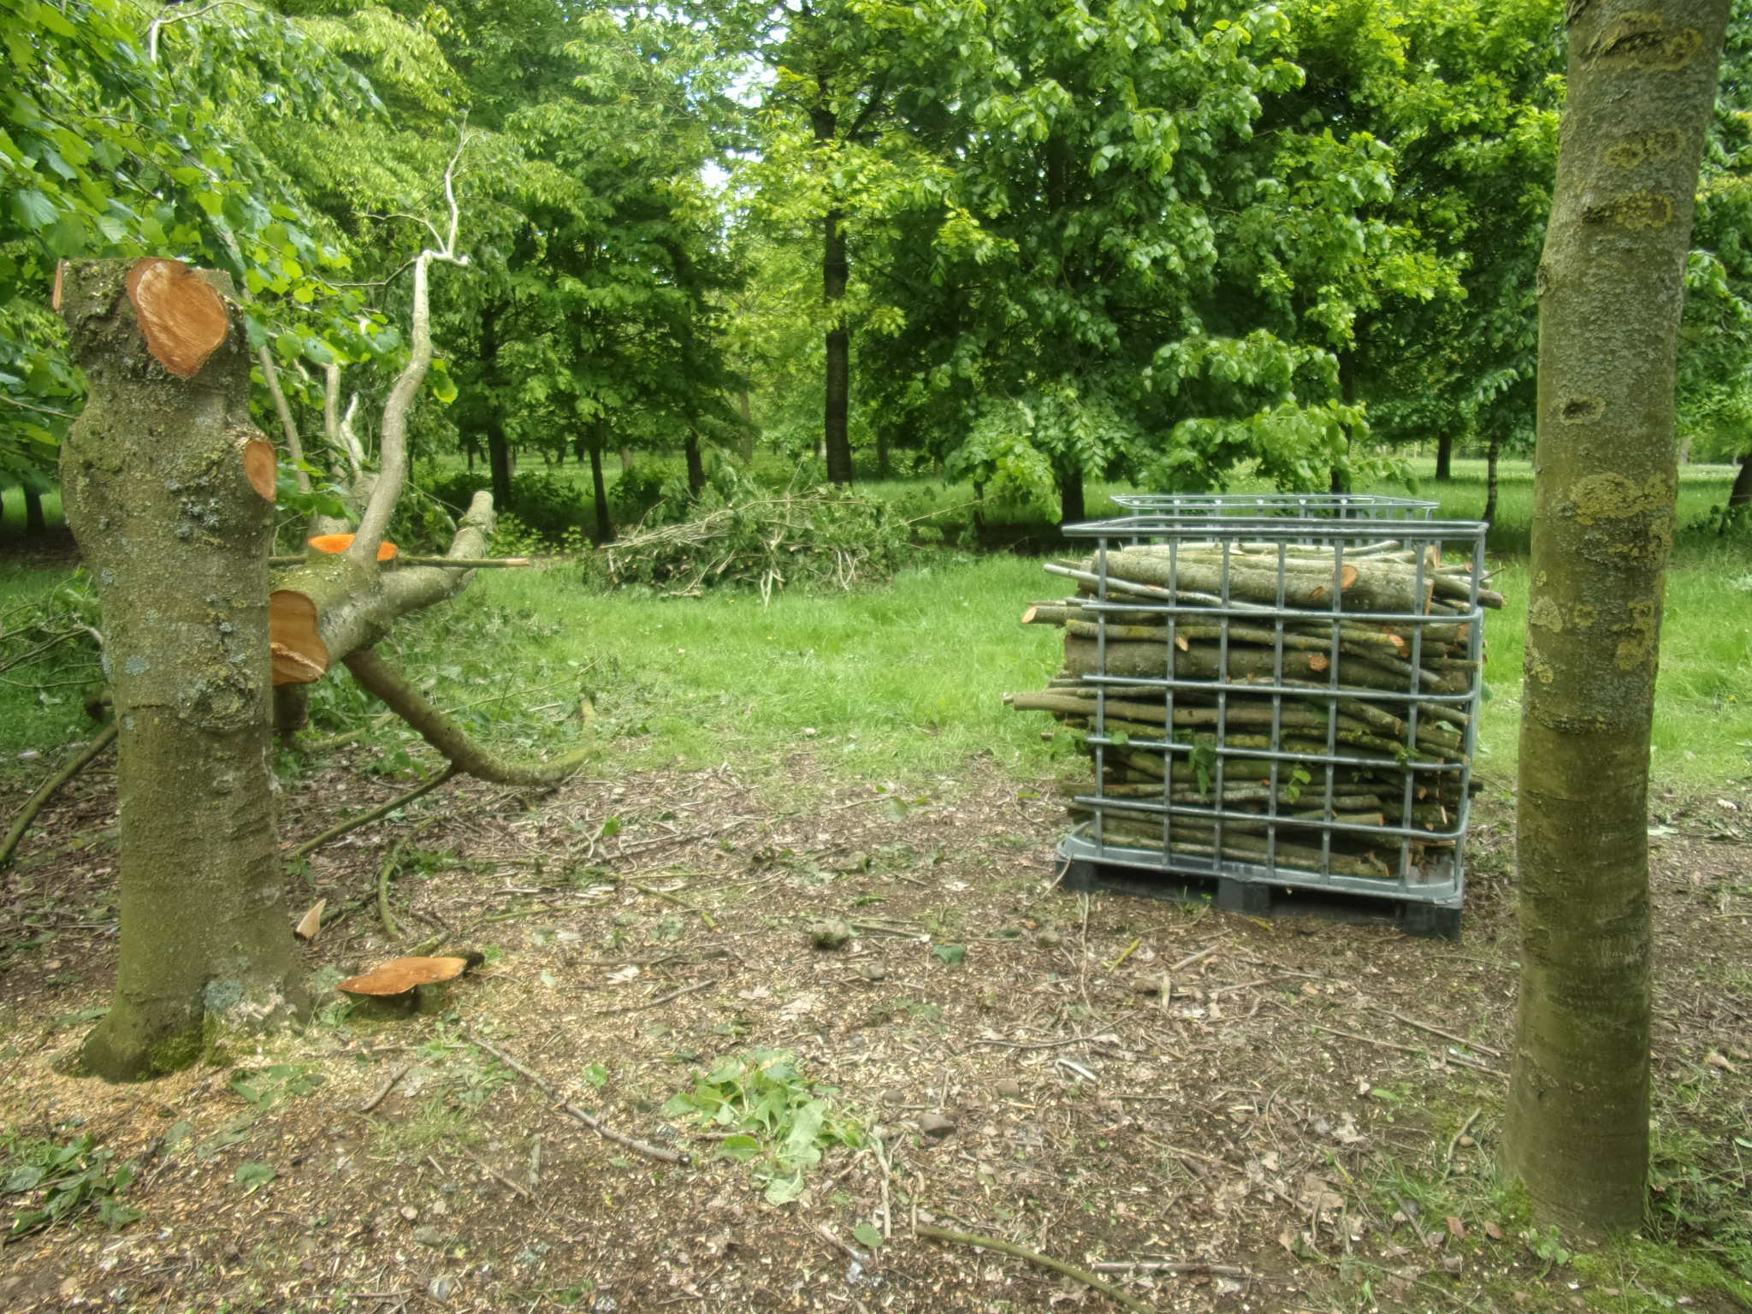
Lime being pollarded at Little Hidden Farm (photograph by Paul Burgess)

The delegates were shown the trees, and the recent pollarding operation. They were also shown an area of farm woodland containing Robinia, sweet chestnut and oak.

David Pilbeam, Jo Smith

