 | “Integrating Farming and Forestry”  Farm Woodland Forum  Annual Meeting at SNH Battleby Conference Centre, Perth  5th and 6th June 2019 | 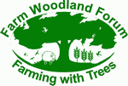

The meeting starts with coffee at 10am on Wednesday 5th June, followed by a morning of presentations, then a field trip in the afternoon and the FWF conference meal and AGM in the evening. On Thursday 6th June we will meet at 09.30 and head out on a field trip followed by facilitated discussions in groups about what we see as potential long term options for a more integrated approach to farming and Forestry. It is the intention to conclude the conference at 3pm on the 6th.

PARTICIPANT DETAILS: Please complete a separate form for each participant
Closing date for Registration is 29th May 2019.

PLEASE NOTE: | First name: | Last name:
Organisation:
Details for name badge:
Address:
 |  | Postcode:
Email:
Telephone:

Membership |  | £
Farm Woodland Forum membership 2019-2020 | £10
Farm Woodland Forum student membership 2019-2020 | £1
Membership of the European Agroforestry Federation 2019 | £10
Registration |  | £
Meeting registration fee for Farm Woodland Forum (FWF) member | £30
Meeting registration fee for bona fide FWF student member | £0
Meeting registration fee for non-member | £50
Meals and field visit |  | £
Lunch on 5th June | £18
Lunch on 6th June | £18
Evening Meal on 5th June | £25

Total (Membership, registration, and meals)

Any special requirements (i.e. dietary/wheelchair access, etc. please give details):

Conference meal and AGM will be held in the County Hotel Perth, they also have 24 rooms for booking at a reasonable rate

Payment details:
By cheque: made payable to “Farm Woodland Forum” (Sterling cheques only)
By bank transfer please use the following information:
Bank: Bank of Scotland
A/C Name: Farm Woodland Forum
Account No: 00190547
Sort Code: 80-06-47
In order that the payment can be easily identified, please ask your bank to ensure that your name is referenced on the payment.
I am sorry but we cannot accept payment by credit or debit card.
Please note: no refunds will be given within 7 days of the date of the event.

Post or e-mail this form to:

John Holland, SRUC Hill & Mountain Research Centre, Kirkton, Crianlarich, Perthshire, FK20 8RU.

E-mail: john.holland@sruc.ac.uk

Telephone: +44 (0) 1838 400524

CLOSING DATE FOR BOOKINGS: Wednesday 29th May 2019

Further details
The meeting programme will be made available on the Farm Woodland Forum website. If you wish to present a paper or poster at the event, please contact Mike Strachan mike.strachan@forestry.gov.scot by Wednesday 15th May.

Accommodation
Please make your own booking. Perth is 5 miles from Battleby and has plenty of accommodation options. Public Transport to the venue is poor, but Taxi services know the site well and you can get a fixed rate.

It might be possible to arrange pick up and drop off in Perth for the event. If this is something you would like please let Mike know

Location and travel information to Battleby
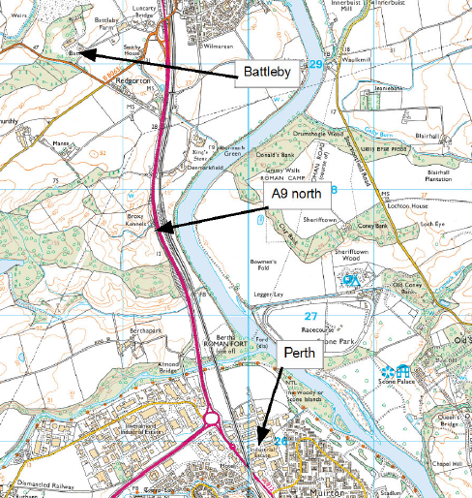
Postcode is PH1 3EN, but don’t rely on it as this takes you to a field. The centre is well signposted from the A9 about 2 miles north of the Perth bypass. First left off the slip then a right turn after about 1 mile, then a right turn (2nd one) takes you into the grounds of Battleby House.

