Farm Woodland Forum 2016 – Field visits

22nd June. Ballyhaise College (Kevin O’Connell)

There are 42 ha of forestry at Ballyhaise College, in 38 plots. The college woodlands are primarily an open-air classroom for the forestry students, where management skills can be taught and practised.

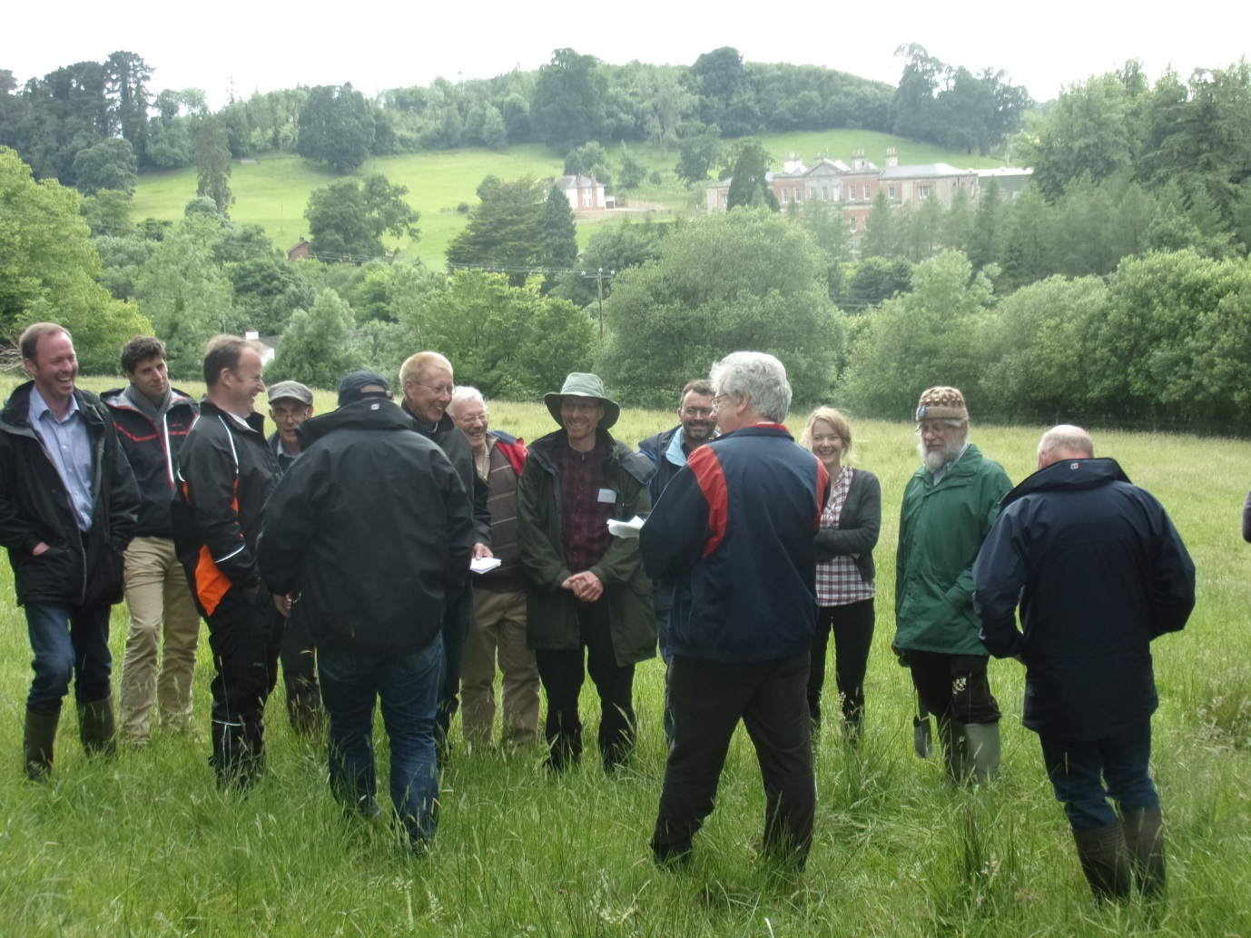
Delegates at Ballyhaise College

The first site visited was a phenological garden, a site in the International Phenological Gardens of Europe network. Trees grown here include 2 willow (Salix) species, Sorbus, hazel (Corylus avellana), Scots pine (Pinus sylvestris) and Norway spruce (Picea abies). For each species various characteristics such as date of bud burst, beginning of flowering, leaf loss and other characters are measured. The garden is situated on a gley-type (clay) soil that is heavy.

Adjacent to the phenological garden is a demonstration of silvopastoral agroforestry. Walnut (Juglans regia and J. nigra), pedunculate oak (Quercus robur), sycamore (Acer pseudoplatanus), cherry (Prunus avium) were planted in 2013 in tall shelters with robust stakes. Sheep are currently grazed in the area, although it can also accommodate cattle as the stakes are strong enough to be used for scratching without being damaged. Because the plot is sheltered by larch to the west (the direction of the prevailing wind), it is good for lambs. Planting costs are estimated to have been approximately €15 per tree, plus the cost of sheep fencing round the field.

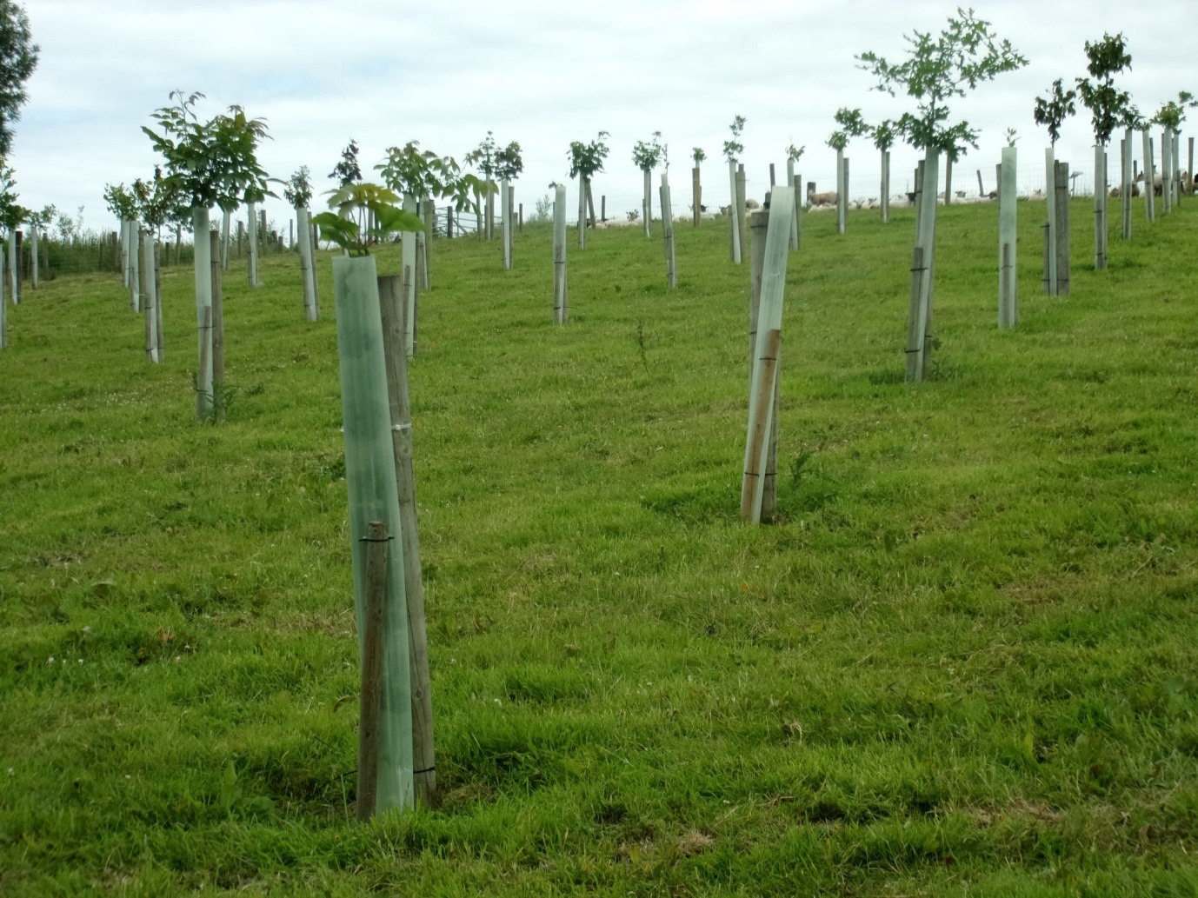
Demonstration silvopastoral agroforestry demonstration plot at Ballyhaise College

Colonel’s Hill
A 0.5 ha site on grey brown podzolic soil
Mature oak, beech and lime were planted in the 1880s as landscaping for the main house. The overstorey of oak was planted in 1919. Younger oak was planted in 1994. There has been no recent management, except that some oak was removed for fencing. There is natural regeneration of oak and beech. There are some cherry trees in the plot. Management of the vegetation is a problem, and this may get worse as some of the young oak are thinned. Grey squirrels are not a problem, probably because of the presence of pine martens.

Replacement hedge by a natural stand of alder
A new hawthorn hedge (Crataegus monogyna) has been planted through a plastic membrane with quarry dust on top adjacent to a stand of Alnus glutinosa on the floodplain of the River Annalee. Some cherry trees have been included in the hedge.

Hospital Field
This is a trial of ash (Fraxinus excelsior) and Nordmann fir, Noble fir (Abies procera) and Fraser fir (Abies fraseri) Christmas trees run by John McNamara, Teagasc, Kinsealy. The Frazier and Nordmann firs have been felled and replanted. Planting, by ‘mounding’, was carried out in 2002 on a 2 x 2 spacing, with 48 saplings of 5 clones. The site is used to demonstrate the management of ash, and shaping and pruning has been carried out by students. However, the potential spread of ash canker across Ireland has led to ash no longer being a recommended species, and ash management will become less important to future students. 100 ash clones have been selected for their growth habits, but it is estimated that ash dieback will kill 95% of the ash in Ireland. Perhaps one of the 100 clones may survive (or even one of the 5 here), although unlike in the UK the policy in Ireland is still to eradicate all ash trees in proximity to where ash dieback is found.

At an adjacent site of 1.2 ha on grey podzolic soil, ash has been under-planted with beech (Fagus sylvatica). Planting, by ‘mounding’, was carried out in 1995. The original ash was brown bud ash (Fraxinus excelsior x F. angustifolia), and had to be replaced. The under-planting with beech occurred in 2004, with some oak and some noble fir also planted. Two thinnings have occurred, one recently. About 45 m³ timber ha⁻¹ has been removed. The timber is ideal for firewood as the bottom of the trunk splits into logs. The top end (down to 5 cm) is not so easy to sell.

Camp Hill
Trials of oak (John McNamara, Teagasc, Kinsealy) and birch (Oliver Sheridan, Teagasc, Kinsealy). There are also Nordmann fir, Noble fir and blue spruce (Picea pungens) Christmas trees planted under power lines.

The birch (silver birch Betula pendula and downy birch B. pubescens) came from the birch improvement programme started in the late 1990s. Improved lines are now being sold, and as the species is fast growing and light demanding they may be suitable for agroforestry.

To augment the small number of Irish silver birch scion material from 36+ trees for obtained from the Future Trees Trust (FTT) Scottish birch group in 2013. One population comes from an area bounded by the rivers Clyde, Forth, Mersey and Humber. This area is the closest geographically to Ireland. The grafted material has been used to establish an indoor seed orchard and gene bank. The seed produced will be used in silver birch trials. Some seed was also obtained from FTT colleagues in 2013, collected from 12 families of the 36+ trees. There were not enough seed for proper field trials, but 3 observational trials have been established in Ireland including here at Ballyhaise.

The oak (Quercus robur) was produced by the root production method (RPM), with air pruning of the roots. The sapling already has a big root system when it is planted, but this technique would be too expensive for regular use.

Colonel’s Hill
Mature pedunculate oak and beech of German provenance planted in 1919. There has been very little management, and cattle graze under the trees. The ground is too heavy for sessile oak.

23rd June. Loughgall , County Armagh, Northern Ireland (Jim McAdam)

Delegates visited the experimental sites of the Agri-Food and Biosciences Institute (AFBI) at Deer Park Farm, Loughgall.

National Silvopastoral Network Site
This site was established in 1989 to a design common to Loughgall, Henfaes (lowland North Wales), Glensaugh (upland east Scotland), Bronydd Mawr (upland south Wales) and North Wyke (lowland south-west England). The initial planting was of ash (Fraxinus excelsior) and sycamore (Acer pseudoplatanus), although the sycamore have mostly been removed as they did not perform well here. One sycamore plot remains, and was being used for grazing by cows and calves on the day of the field visit.

The ash were planted at a 5 x 5 m spacing, giving 400 trees ha⁻¹, replicated three times. Additionally, there were blocks of ash at 2500 trees ha⁻¹ to give woodland controls. The agroforestry plots were grazed by sheep from planting, and after about 5-6 years the trees were robust enough to withstand rubbing by cows so cattle grazing was also practised. By 2014 the agroforestry trees were marginally taller than the woodland control trees, and they had considerably larger girth from 1999.

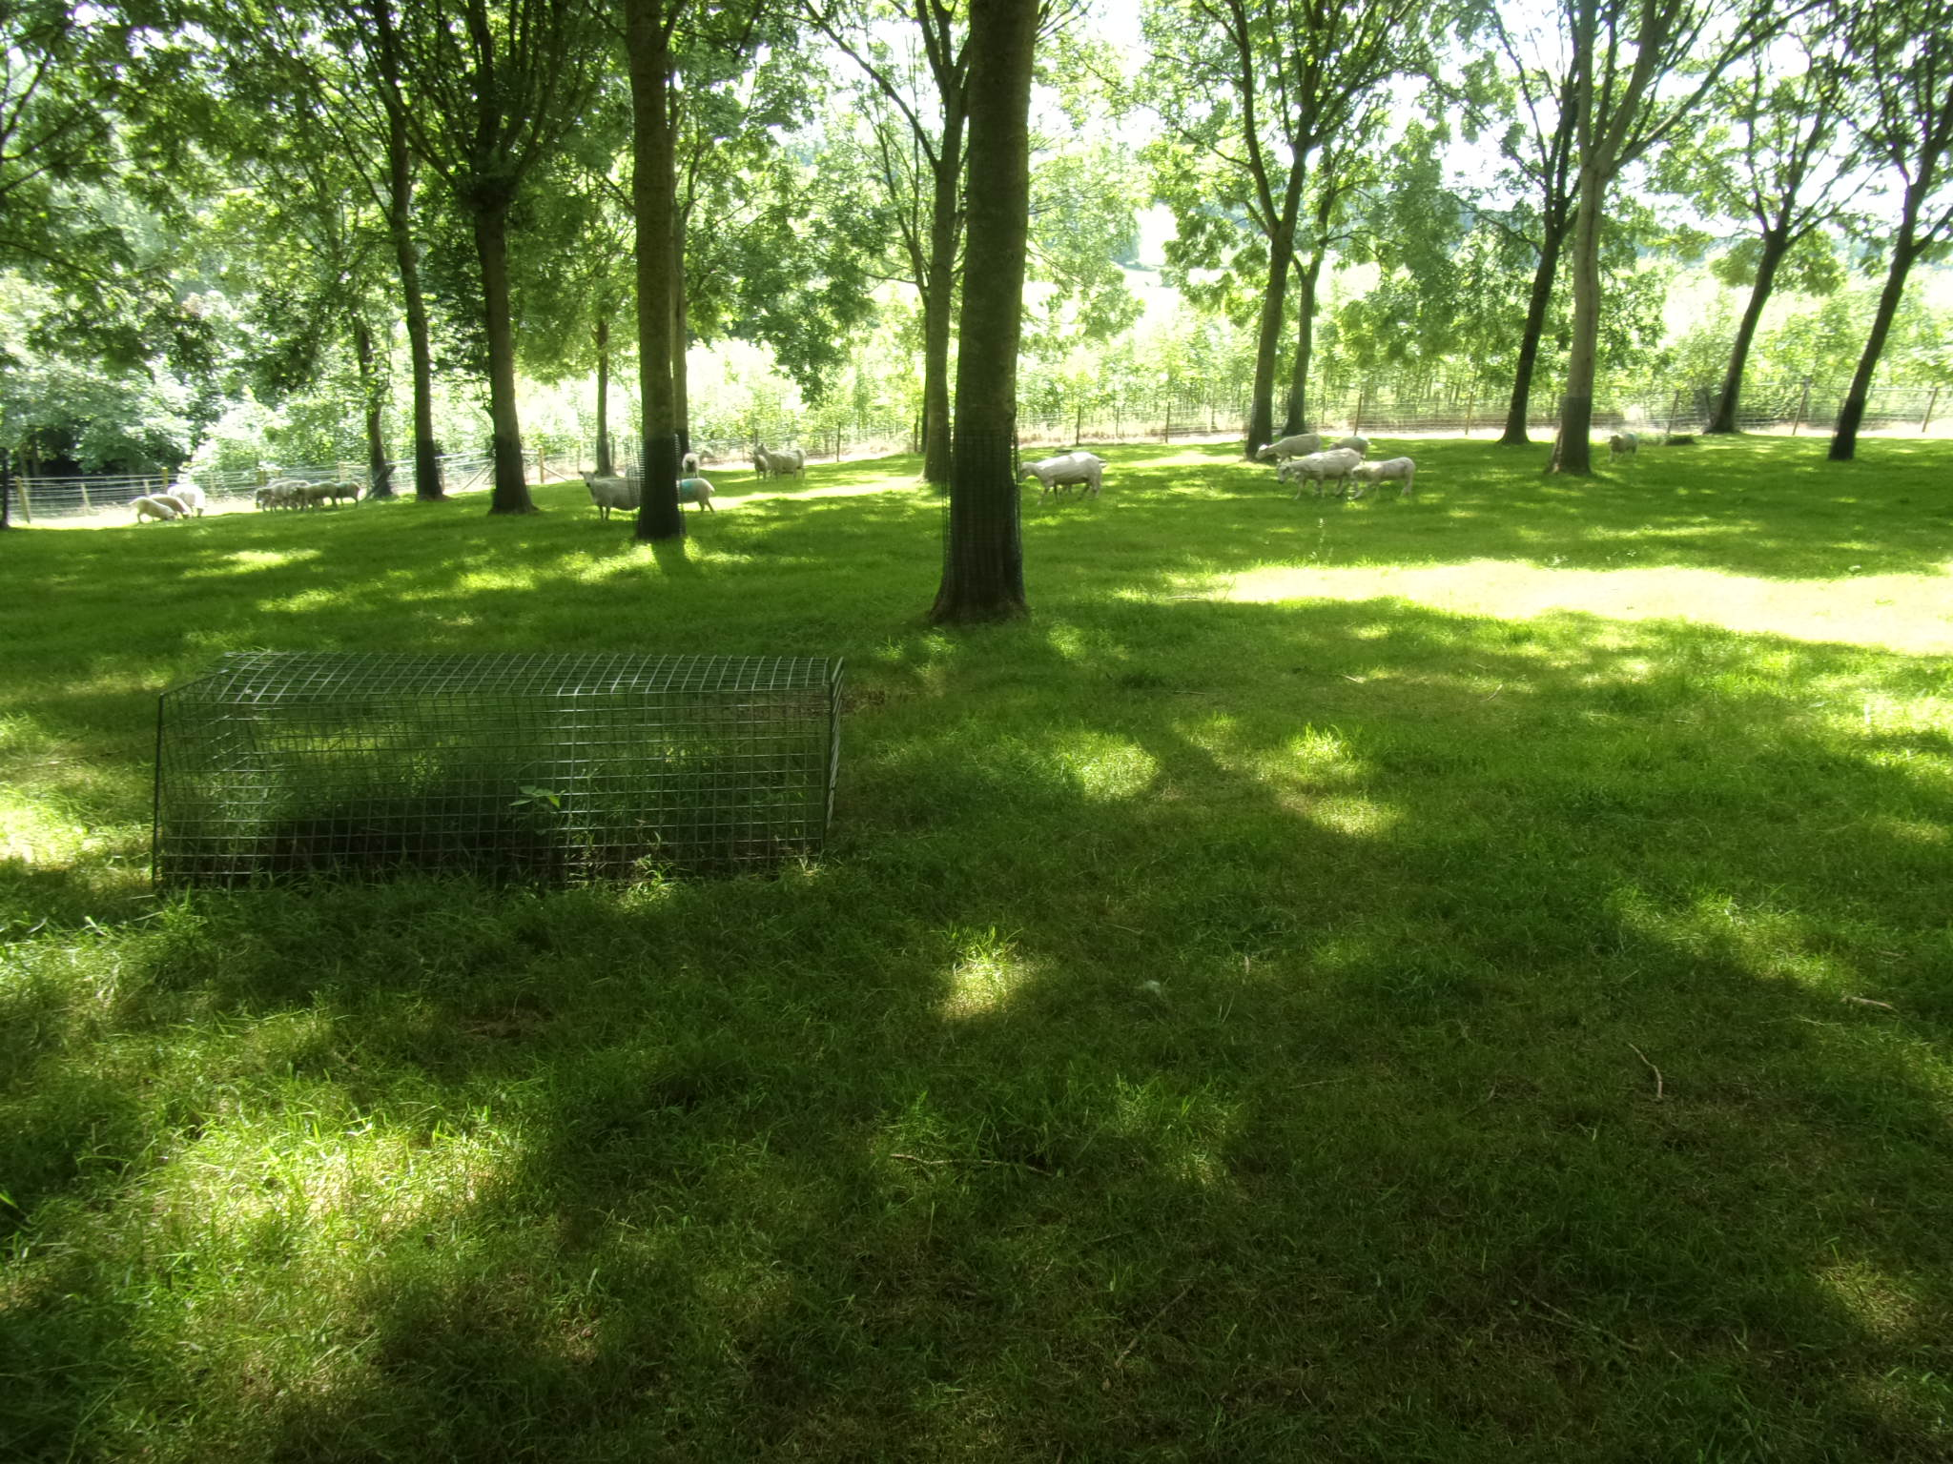
Texel sheep under the ash trees at Loughgall

So far there have been two thinnings (2001 and 2013) of the agroforestry ash, down to half density of 200 trees ha⁻¹. The trees were cut low to the ground and the bottom part of the trunk was sold for hurley sticks. The quality of the stick was particularly good as the trees had grown fast in this system, giving a good spring to the wood. The upper parts were sold for firewood. Where the trees were cut down there has been no subsequent regrowth due to grazing. The target density is 120-150 trees ha⁻¹, and another thinning is due.

The first thinning raised approximately €1000 ha⁻¹and the second thinning approximately €400 ha⁻¹. Income from the sheep remained high as grass yields under the trees did not decline until 11 years after planting. Better pruning could possibly have delayed this decline. Interestingly, although grass yields started to decline, sheep production was not affected initially (sheep liveweight gain was maintained on a lower grass yield). Over time the grass species composition has changed; it was initially all ryegrass, but now ryegrass comprises about 20% of the species. Work on soil carbon in the plots in 2015 (P. Burgess) showed there was less carbon in the surface layers under the trees than in the grassland control plots (counter to expectations).

It was noted by one delegate that under the new regulations, in order to maintain grant income in Scotland agroforestry trees have to be kept at 400 trees ha⁻¹ for 20 years after planting. Farmers in Northern Ireland who are aware of the trials at Loughgall like the flexibility of the system. They can remove trees, or some of the trees, and still receive grants (in Northern Ireland agroforestry is classified as ‘agriculture’, unlike in Ireland where it is ‘forestry’).

Clonal Cherry Trials in Ireland (Gerry Douglas, Future Trees Trust)
A trial of 31 cherry clones was established at 3 sites in Ireland (Loughgall, Donard and Clonmel) in 2009. Wild cherry (Prunus avium) grows naturally in Ireland, where it grows faster than most other broadleaves. The threat to ash from ash dieback gives added importance to finding other species to plant on farms. Many of the clones trialled here come from European stock grown in Germany since the 1930s, together with the UK Wildstar clone and local Irish cherry as a control

The trees at Donard have been damaged by deer, and those at Clonmel were destroyed after an outbreak of ash dieback, but the Loughgall trees are performing well. The trees were initially planted with an ash nurse crop; the ash saplings are starting to be overshadowed by the cherry, and will soon be removed.

Cherry agroforestry with SRC willow (Rory Lunny)
A trial was established in 2013 in which 6 cherry clones (5 German clones, Concordia, Hermes, Neso, Pluto and Saturn and the UK Wildstar clone as control) were grown in rows, with 5 European and Swedish clones (Beagle, Endeavour, Olaf, Resolution and Terra Nova) of short rotation coppice (SRC) willow in alleys between the rows, and different width of buffer strip between the cherry tree rows and the willow alleys integrated into the design. At the time of our visit the SRC willow had been cut 3 months earlier, and was re-growing.

Wildstar and Hermes had performed less well than the other cherry clones to date, and differences could be seen between the different willow clones although it was still early in their production cycle.
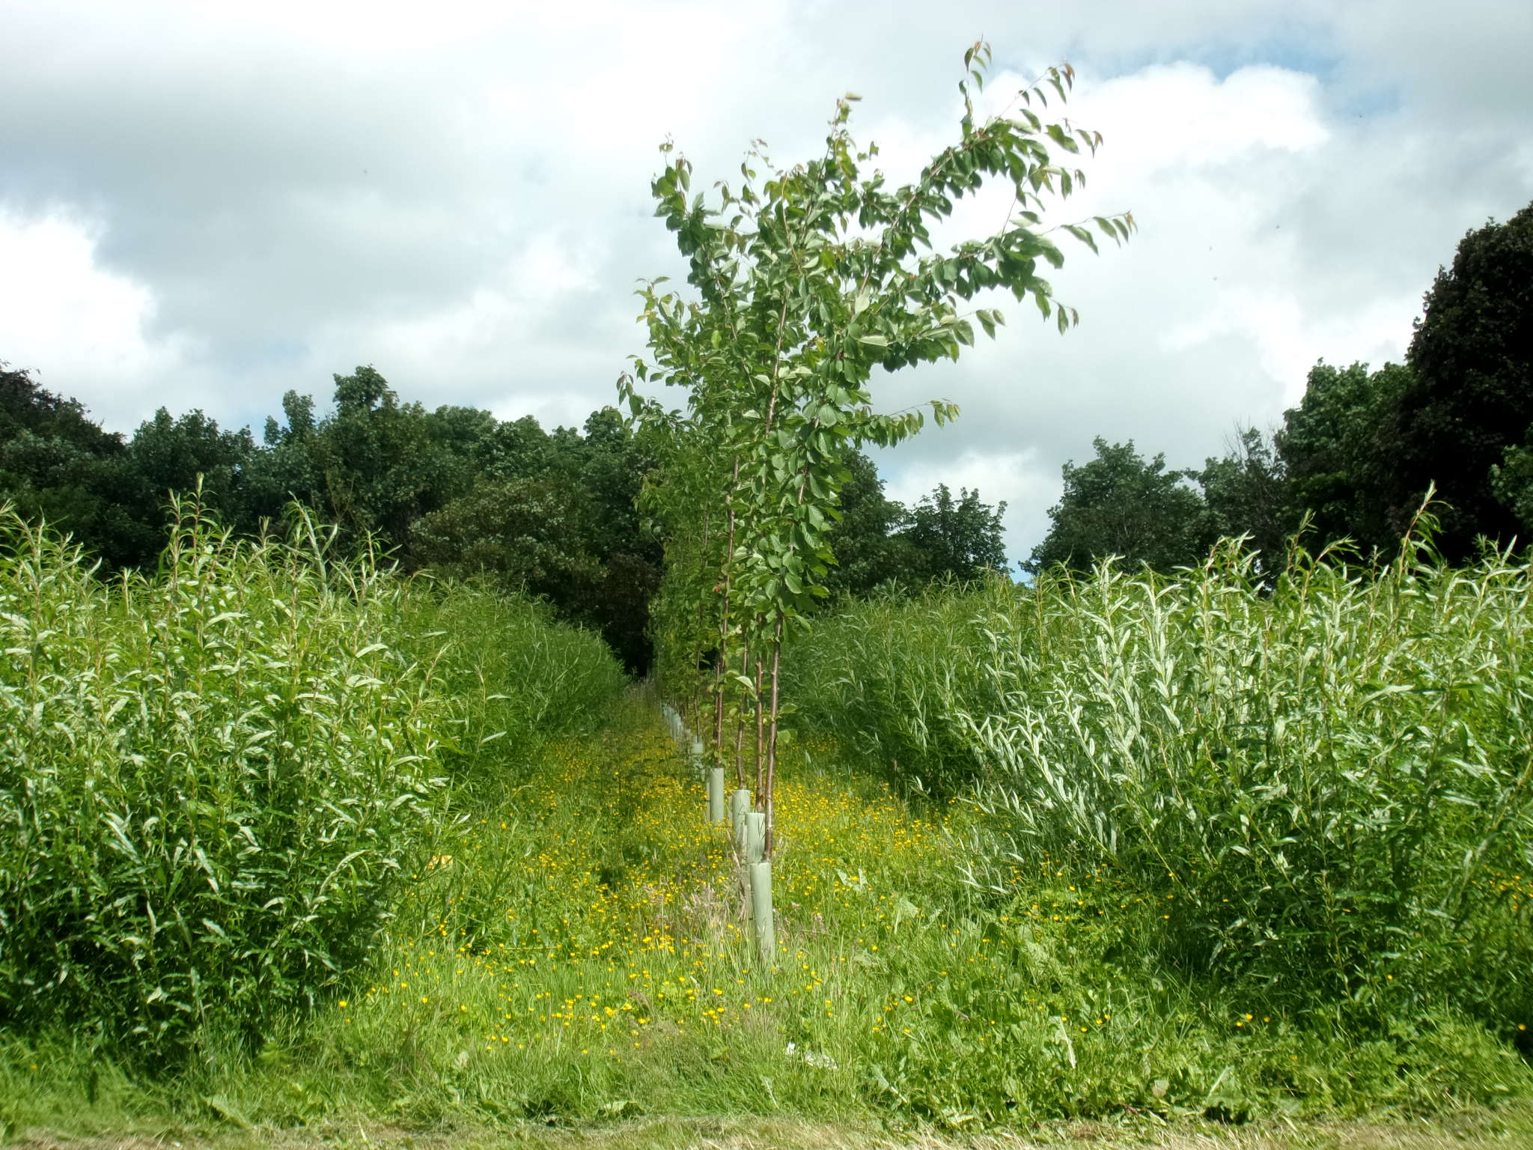
Cherry tree row with SRC willow in the alleys

The delegates were also shown an earlier experiment where SRC willow was grown in alleys between rows of poplar, re-using a poplar silvoarable agroforestry trial. The yield of the outer rows of the willow (i.e. closest to the poplars) was very badly affected by the poplars.

Grazed orchards in Northern Ireland
Delegates were shown a field trial that is part of the EU AGFORWARD project. Here sheep graze in an apple orchard.

Northern Ireland has a small apple orchard sector, (approximately 1,200 ha) concentrating mainly on cider and cooking apples. ‘Bramley Seedlings’ account for 99% of production, with the other 1% being dessert apples and cider apples. In the orchards the delegates were shown sheep grazed under a dessert cultivar (Jonagold) and a cider cultivar (Coet de Ligne). The trial was implemented in 2015 in an orchard planted in 1998 with the expectation that the sheep would provide an extra source of income for the apple grower, and also that as apple scab is carried over between seasons on fallen leaves the presence of sheep to remove these leaves would lower incidence of scab.
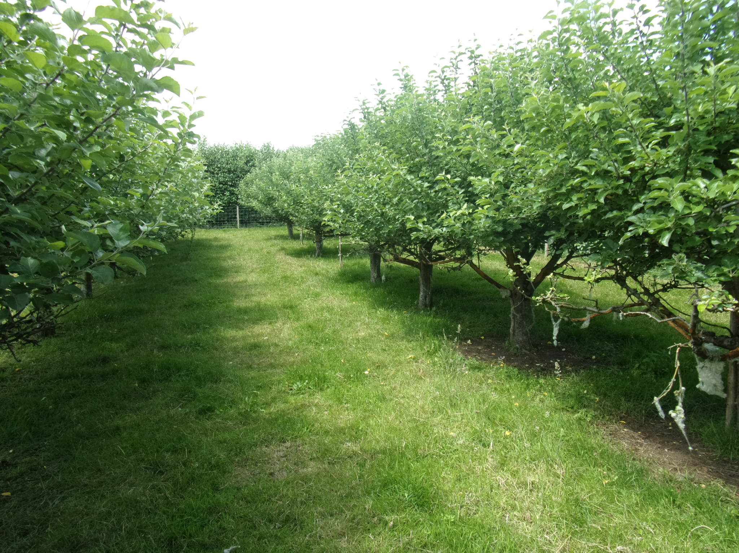
Coet de Ligne apple trees with grass alleys

It has been found that sheep graze the lower tree leaves, and apple yields have been reduced by up to 50%. There has been virtually no bark damage, despite the sheep being Texels and not the Shropshires known to cause less damage to trees, so trees pruned higher might avoid this grazing. However, the trees are grafted on dwarfing rootstock to give bushes, as currently used commercially in Northern Ireland. At this size they can be picked by hand (which is important for the dessert apples, although cider apples are currently allowed to fall to the ground, a practice that is only possible if the sheep have been excluded for at least 50 days before harvest). It has been noted that sheep graze the leaves of Jonagold more than Coet de Ligne. The sheep seem to put on liveweight better in the orchard that in grass-only control areas.

Sycamore Seed Orchard (Gerry Douglas, Future Trees Trust).
This site is funded by the Future Trees Trust.

Comparison of Root Production Method (RPM), Cell Grown and Bare Root Oaks
The trees are currently 14-16 years old. The RPM-produced trees have grown faster than the others, and started producing acorns after 5 years, but RPM would be prohibitively expensive for commercial production.

David Pilbeam
Photographs by Paul Burgess

