A Coppiced Hedge
Converting a flailed hedge into an economic crop of firewood

Ross Dickinson, Racedown Farm, Dorset

Foreword

To be healthy and ultimately to survive, hedges have to some value to farmers. They must be seen as an asset, not a drain on resources. If they can pay their way, or better still provide an income for the farmer or contractor, so much the better. In this context, the experiment that Ross reports on here is truly ground breaking: it has the potential radically to change the way many farmers view their hedges and how they manage them.

Ross is exceptionally well-placed to have carried out this work. Not only is he passionate about hedges and keen to promote rural employment, he is also a practising farmer and together with his son Euan runs a successful firewood business. As such he sees the arguments from all sides. Together with his modest and careful approach, this gives me complete confidence that the conclusions he presents are valid, and that the methods he proposes are practical for use on commercial, working, farms. I am sure he will inspire many others, just as he has me.

Dr Robert Wolton
Hedgelink
Chairman, Devon Hedge Group

Introduction

This paper will demonstrate that it is economically viable to move a hedge from annual flailing to a fifteen-year coppicing rotation using our methods and applying our circumstances.

It has been shown by others that the most efficient method is complete chipping of all material and the subsequent use of this material in biomass burners, both in terms of profitability and energy output. The problem with this process is that there is not currently enough demand for this type of material due to various factors including; many boilers not running well on this type of rough chip and that the current demand for chip in general is well below the potential supply. It may well be that in time we will achieve a complete supply and demand cycle as in certain areas of the continent, if this was achieved on a scale that could absorb all the material from hedges then it is likely that this process will be widely adopted.

If the example discussed here has any merit it is in its ordinariness. If this process is viable on our farm using our techniques then it should be widely applicable, or to put it more crudely, if we can do it then anybody can do it. The process used here requires no particular skill set, no special equipment and no demand for new capital. This paper will not provide a template for others to adopt as it is site specific but it does demonstrate that in certain circumstances it is viable to take some hedges from flailing to coppicing and that there will be parts of our process which others might adopt to their own circumstances.

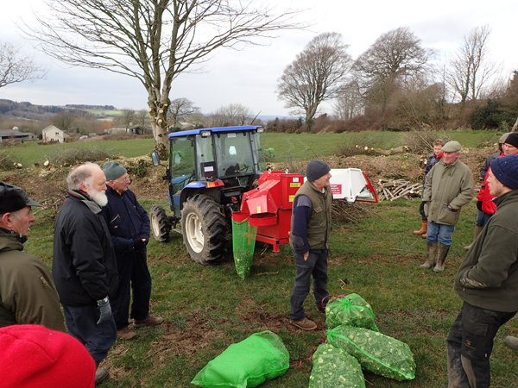
The author (centre) telling visitors about the experiment.
Note branch logger behind me, and net bags with mini-logs (cobs) it has produced.

The Farm and its Firewood Business

The hedge considered here is on our family farm in Dorset, the farm is about 400 acres divided into two parcels, the altitude is from 400 to 1000 ft. with above average wind speeds and six miles from the sea. The soil types are predominantly a range of heavy to light loams with a considerable amount of surface chert, they are mainly grade three. Hedge growth depends upon a number of variables including, soil type, species content, wind speed, altitude and proximity to the sea. Our hedge growth would be below average for the South-West of England. In the most favourable environments in this region the hedge growth could well be nearly double that on this farm.

The farm is a low intensity grass farm, mainly providing grass crops and grazing for larger units. It should be noted that on farms with a significantly higher labour requirement there would probably not be the time for this work to be done in house. However, if it is viable it might provide an opportunity for contractors to do the work. There are four families who live on the farm spanning four generations, we have eight log burners so our own demand for wood fuel is significant. The farm has some twelve miles of hedges, with field sizes varying from one to thirty acres. All the hedges are managed on a 15/20 year coppice rotation except those bounding public roads which are annually flailed. Amongst other enterprises we have a small firewood business, which the hedge products contribute to.

The firewood business sells about 175 tonnes of air dried logs a year, approximately half is sold bagged in 18Kg cattle feed bags ex farm the remainder being sold in loads from a long wheel based truck. All loads of wood are sold locally (within four miles) which only supplies some of the demand from local villages, the nearest market town being six miles away. The material is supplied from our hedges and small copses, wind thrown trees, some tree surgery work, hedge material from our neighbours, thinnings from growing woodland and deliveries of timber from timber companies. The hedge material bought from our neighbours does offer a small cash incentive to carry out remedial work on over stood hedges. In this sense, the business acts as a wood market for approximately 25 miles of hedgerow in total.

The bagged firewood is sold for £194 per tonne while the loads are sold at £169 per tonne based on moisture content of 20%. The quantity of wood sold has risen each year; this has been accompanied by a modest annual price increase. Our customer base numbers about two hundred with a demand range from 200Kg to 5,000Kg each year. Due to the cold spring we ran out of logs this year. The bagged logs are sold through an honesty box system which due to its location well inside the farm has a low theft rate of 2%.

The hedgerows produce four products. First, round and split logs. The public will accept more round logs (4-8cm diameter) in a load or bag than split logs, provided split logs from trees are mixed in with them.

Secondly, hedges also produce a large quantity of small diameter material which is often burnt as brash. This material is difficult to sell to the public as they do not like buying wood with even a modest percentage of this material. These “ugly sticks” are used on our own eight log burners while some are sold to glamping and camping business for open fires at £150 tonne delivered. Currently all this material is being used or sold.

The third product the hedges produce is bags of “cobs” of small diameter material (2-4cm diameter) which derive from hazel rods and other smaller branches. These branches are tidied with a bill hook and then fed into a branch logger which reduces them into small cobs (5cm long) and drops them into nets. These cobs have been sold to clients with very small top loading log burners, for example, in shepherd’s huts and boats. The cobs are sold at £190 per tonne. This hedge produced 99 nets of cobs, each net weighing 30Kg.

Fourthly there is some of the brash material, this is also fed through the branch logger and produces nets of kindling twigs. Currently we are able to sell or use about 30% of the viable brash in this way, it should be noted that some species are not suitable for sale, for example, the thorns and holy. The kindling nets are sold at £190 per tonne. This hedge produced 263 nets of kindling twigs, each net weighing 15Kg so 3.945 tonnes.
Due to our fire wood business and heavy domestic use we are able to sell or use a large percentage of the total hedge material, approximately 70% of the total hedge biomass; on other farms it may not be possible or practical to use such a high percentage.

All of the farm’s hedges are under a coppice rotation, with the benefit of hindsight, it might have been better not to put the hedges with a high thorn content into the rotation. When considering taking a hedge out of annual flailing and into a coppice rotation a number of factors should be born in mind. Select a hedge which is not by a public road, one that has a high percentage of viable species, for example Sycamore and Ash, avoid a hedge which bounds high value crops as there will be some shading and possible fallen material, it has relatively easy access for abstraction, growth rates affected by wind speed and altitude and distance from processing site.

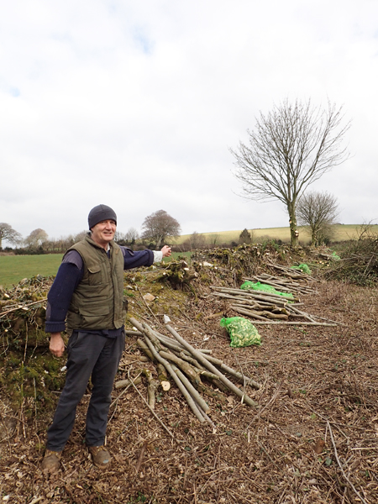
By the experimental hedge!

The Selected Hedge
The hedge selected for this analysis had the following characteristics:

- The species content was 25% thorns, 25% Sycamore, 5% Ash, 10% Hazel, 10% Holy, 10% Willow, 5% Field Maple, 5% Oak and 5% Bramble. This hedge was selected as it was judged to be of average species composition for the purpose of this study.

- The hedge was 15 ft. wide and averaged about twenty feet in height. It was on an old hedge bank, which, although eroded was some 3ft. tall. It was 220 meters long.

- The hedge is at an average height above sea level of 600 ft. and the wind speed is fairly high here as it is a fairly exposed site. Rainfall is above average for West Dorset and the soil is acidic medium loam with large pieces of chert and is classified as Grade Three.

- It had old barbed wire fence lines on both side. The time taken to remove these was included in costings, and no new fences were put up.

- It is within half a mile of the processing site and abstraction was relatively easy.

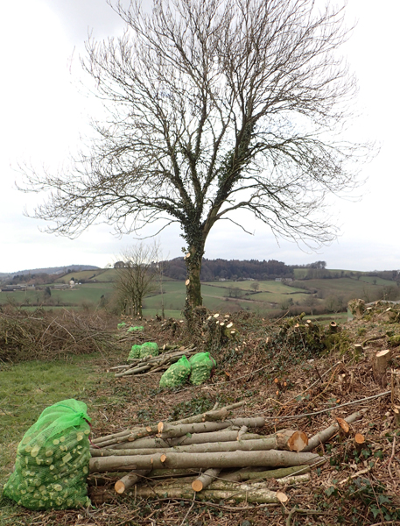
The hedge after coppicing,
with stems for logging and green net bags full of cobs from branch logger

Method

The work was done when I had a spare few hours, often only three hours a day.

Ironically the first job was flailing back the sides of the hedge being severe with patches of thorn and brambles. Time taken was two hours, at £30 per hour so total cost of £60. The hedge had been allowed to grow for fifteen years.

The coppicing was done using a small chain saw, initially the thorn and brambles were removed and heaped up to be burnt. The hedge material was cut some 2 inches above the ground. The material was then reduced into four constituents, saleable cord wood, ugly sticks, rods (for cobs) and viable brash which was kept separate from other brash which was to be burnt. Standards from a previous rotation were trimmed and new standards left where there was significant gaps. The gap left was comparatively small as during some later rotation some standards can be taken for fire wood. The time taken was 88.5 hours, which if priced at contracting rates of £15 an hour gives a labour cost of £1327.50.

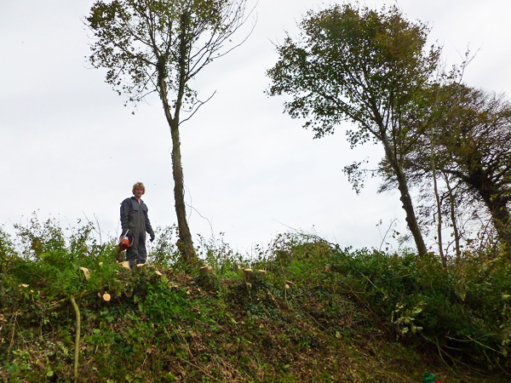
My son, Euan, on the coppiced hedge. Note the retained standards

The selected brash and rods were then processed by the branch logger into nets of material. The branch logger was operated by two men and was processed in 20 hours, when hired out we charge £30 per hour so on this basis cost was £600. The nets were hauled and stored by two men in four hours, assuming a rate of £12 per hour then the cost was £96.

The brash was heaped up and burnt using a materials handler in several different fires, time taken was five hours at £25 per hour so cost £125.
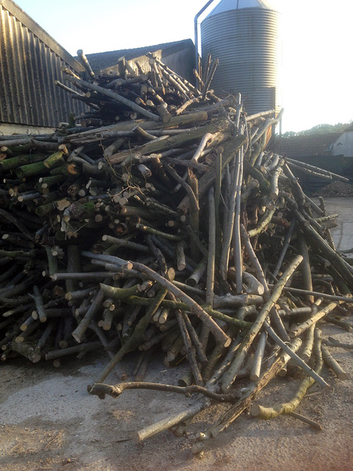 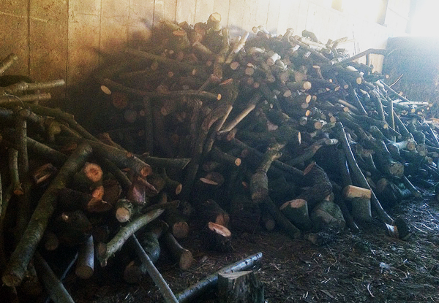 Ugly sticks from the hedge Sellable log material from the hedge

The cord wood and ugly sticks were loaded manually into a materials handler bucket and tipped in separate heaps at the processing site. This process took two men six hours at a cost of £30 per hour so cost of abstraction was £180.

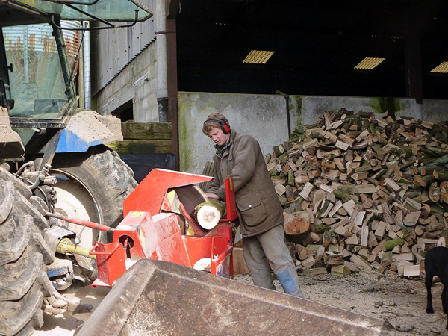
Processing the logs with a saw bench

The few rounds of wood were logged with a splitter, some 20% of these were distorted and were kept back for domestic consumption. The “ugly sticks” and saleable cord wood were processed with a saw bench and cut into 8 inch logs except about 20% of the “ugly sticks” which were cut into 2ft lengths for sale for open camping fires. There were fifteen tonnes of this material which took 30 hours to process at a rate of £25 per hour so a cost of £750.

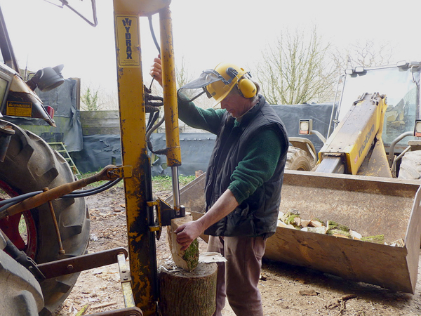
Using the log splitter

This hedge produced nine tonnes of saleable logs, six tonnes of “ugly sticks”, ninety-nine bags of cobs and two hundred and sixty bags of kindling twigs.

Usually timber sales are assessed in cubic meters but here it will be evaluated in weight, all the weight measurements given here will assume a moisture content of 20% which is the moisture level at the point of sale while in fact all the hedge material is processed when still relatively green for ease of processing and to speed up the drying time. The processing rate for both the rounds and cord wood is about two hours per tonne, if a small tractor, saw bench and man are valued at £25 per hour then the cost of the processing is £50 per tonne.

When sold locally a half tonne load can be delivered and manually unloaded in an hour, so delivery costs in the region of £20 a tonne. It takes about an hour to manually bag a tonne of logs so the cost of sales of the bagged logs is £12 a tonne. Given that the sale of wood is equally divided between the two the average cost of sales delivery is £16 per tonne.

Results: costs and income
NB. Hedge length 220 meters.

Costs £
Initial flailing 2 hours @ £30 per hour 60.00
Manual coppicing 88.5 hours @ £15 per hour 1,327.50
Processing using Branch Logger 20 hours @ £30per hour 600.00
Abstraction cost of nets 8 hours @£12 per hour 96.00
Abstraction cost of cord wood 6 hours @ £30per hour 180.00
Brash burning cost five hours @ £25 per hour 125.00
Processing cord wood and ugly sticks 750.00
Cost of delivery of fifteen tonnes @ £16 per tonne 240.00
Total 3,378.50

Income/savings £
Savings of annual flailing cost @35p per meter
For fifteen years over 220 meters. 1,155.00

263 x 15Kg nets of kindling twigs
3.945 tonnes @ £190 per tonne 749.50

99 x 25Kg nets of cobs
2.475 tonnes @ £190 per tonne 470.50

6 tonnes of “ugly sticks”
£150 per tonne 900.00

9 tonnes of saleable logs
£181 per tonne 1,633.50

Total 4,908.50

PROFIT £1,530

It will be noted that this profit has been arrived at without any subsidy from any environmental schemes. The current support for hedge coppicing is £4 per meter, if this support could be obtained then it would add a further £880 to the profit, giving a profit of £2410 or £10.95 per meter spread over the fifteen year cycle. If a farm switched from flailing to coppicing it would increase its “natural capital” which given the probable nature of the changes post Brexit might help the farm attract more support.

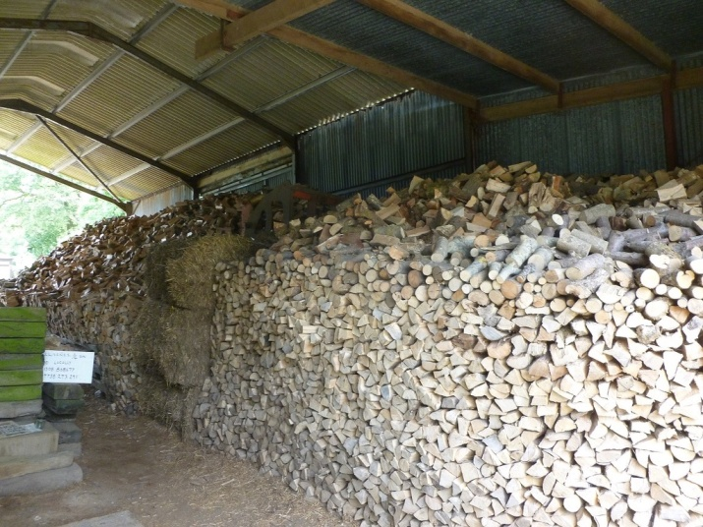
Air-dried logs awaiting sale
Conclusion

There are too many variables to make this example anything but a general guide. One key variable is the age and fitness of the coppicer, when working with my son it was very clear that he was covering nearly twice the distance that I was per hour. It seems reasonable to say however, that it is economically viable for a hedge to be taken from an annual flailing regime to a fifteen-year coppicing system. If a hedge was coppiced under circumstances approximately similar to this then the coppicer could earn a living wage while undertaking this work. If a coppicer would accept these payment rates then it does make it viable to employ outside labour on farms where the current workforce does not have the time.

The disadvantages to this transition are that the nature of the growing hedge would impact on nearby crops in the adjacent fields. These disadvantages would include some shading, shortage of water and consequent crop retardation near the growing hedge and some fallen material into the fields towards the end of the fifteen-year cycle.

There will also be some loss of usable land, this will be in the order of two meters each side of the hedge by the end of the fifteen-year cycle.

The advantages are numerous:
- The change may entitle the farm to a coppicing grant of £4 per meter and may contribute towards further environmental support.
- The farm would have an approximate saving of 35p per meter for each meter incorporated in the switch from year one and running continuously for fifteen years. The total saving over the fifteen-year period would be £10.95 per meter.
- If the farmer wished to do the coppicing himself then he could earn a living wage through savings and sales of product using the above model.
- If the farmer employed a coppicer then he will at least save the cost of the flailing.

The advantages to the wider society would also be significant:
- It would improve the biodiversity on the farm - due to the differing growth stages the hedges would create a diverse range of habitats for both flora and fauna.
- It would be a method by which hedges were in a better state of health.
- It would produce locally produced renewable energy to supply local demand.
- As it is renewable the energy produced it is almost carbon neutral, this 220m of hedge produced some 21.41 tonnes of saleable or useable material which will produce some 88MWh of heat energy.
- Given that 1Kg of wood at 20% moisture content produces 4.1KWh of heat energy then this 220m will produce the equivalent heat output of 8,500 litres of heating oil after fifteen years growth.
- There would be some new employment opportunities in the countryside given that the most of the existing workforce is overstretched.
- There would be an increase in the amount of carbon sequestration, both in the woody mass of the hedges (until they were coppiced) and in their more extensive root systems and in the growth of more standard trees.
- Healthy large hedgerows will reduce flooding risk by reducing run off as well as reduce the organic and inorganic pollutants.
- A coppicing regime would increase the size, health and value of hedges which in turn would maintain and enhance the landscape for the public.

Many of these attributes of healthy hedges benefit society as a whole and attempts are already being made to express their value in monetary terms, while in its infancy the value placed on the functions of hedges is very significant and may in the future be of some benefit to those that look after them.

If 5% of England’s hedgerows were taken into this type of rotation from flailing it would amount to thousands of kilometres of hedges and the scale of the benefits to society would be considerable.

Perhaps, above all, if the hedgerows can be perceived as economically viable rather than just a necessary cost then this change in perception would give them a much securer future.

Acknowledgements
I would like to thank my wife, Madge, for putting up with me grumbling about the weather and the days out she missed. My son, Euan, for helping me with the work. My thanks to Henry Gent and Tim Frost for providing me with data which, when combined with that from other farms, allowed me to arrive at an average flail cost per meter. Above all I would like to thank Rob Wolton for his encouragement, advice and help in getting this paper finished.

Ross Dickinson 13/6/2018 thanefarm@hotmail.com

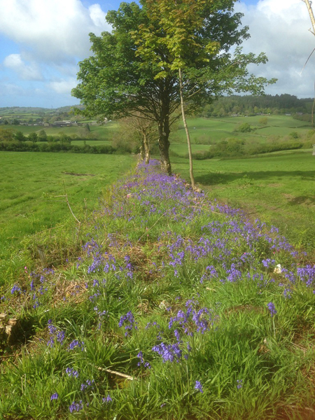
The hedge in spring following cropping

Organic Research Centre, R. Wolton et al.
Amongst which are parts of Brittany and Normandy.
Due to the low intensity, we do have time to coppice half a mile a year of hedgerow.
Barn dried for 10 months. This reduces the moisture content to about 20%.
I estimate that this business only caters for the total demand of one small village.
Our neighbours tend to supply larger material from over mature hedges which have been unmanaged for sixty to eighty years.
Average price being £181.50.
It should be noted that we are on a relatively busy B road and bagged log sales on more remote sites could well be more limited.
The cobs are heavy and sold by the half net say 15 Kg for £3.
The kindling twigs are sold in very full nets say 15Kg for £3.
Due to ash dieback this may not be an available option in a few years’ time.
An approximate figure as judged by eye.
Concern is sometimes raised about the cost of new fencing under this regime but given the nature of modern fence posts they need to be replaced anyway after 15/20 years.
It may well be that some farmers would be prepared to do the work for £10 per hour if they were using gaps in their working day. Many professional hedge layers like to achieve £25 per hour to give them a reasonable income.
All the wood for this business are stored in large redundant farm buildings with a good air flow. We always try to store it for 10 months to reduce the moisture content to 20% or less.
Predominantly the willow.
One cubic meter of fresh oak wood is about one tonne, when dried to 20% moisture, logged and loosely stacked the volume increases to three cubic meters per tonne for oak.
It has been at hedge side for say 4 months.
A sample of flailing costs were taken from a number of farms and averaged. These costs varied considerably and were dependent on a number of variables the most significant of which was hedge size which determine the number of flail passes.
These include the work rate of the coppicer, the nature of the hedge and its accessibility, the distance from the processing site and above all the ability to sell the products and their price.
This is assuming the hedge products had a realizable value to him.
Some flailed hedges are in a poor condition due to continual flailing.
Assumes an efficient modern log burner.
A county with a small economy like Dorset spends more than a billion pounds a year on fossil fuels. If more use was made of local fuel sources then a little of this money would stay within the county. If 100 Km of hedgerows were taken into this system then some 1.5 million litres of heating oil would not need to be bought, at 40p litre this would be worth £600,000. (Based on 1 litre of oil giving 11.63 KWh of heat energy and 1 litre of oil weighing 0.89 Kg.)
These jobs would often be available in the most disadvantaged rural areas.
Caubel et al. 2001.
There are some 500,000 Km of hedgerows in England.

